[Institution name]
[Institution address]
[ Institution logo ]
Insert the institution logo here.
Department of Computer Science and Engineering
A Major Project Report
On
EdgeLegal: Privacy-Preserving Contract Analysis & Contradiction Detection
Submitted in partial fulfillment of the requirements for the award of the degree of
BACHELOR OF TECHNOLOGY
in
COMPUTER SCIENCE AND ENGINEERING
by
S.No. | Name of the Student | Roll Number
1 | [Student name] | [Roll No.]
2 | [Student name] | [Roll No.]
3 | [Student name] | [Roll No.]
4 | [Student name] | [Roll No.]
Batch No: C7 [to be confirmed]
Under the guidance of
[Guide name], [Designation]
Academic Year 2026-2027

[Institution name]
Department of Computer Science and Engineering
CERTIFICATE
This is to certify that the Major Project entitled EdgeLegal: Privacy-Preserving Contract Analysis & Contradiction Detection is being submitted by [Student name] ([Roll No.]), [Student name] ([Roll No.]), [Student name] ([Roll No.]) and [Student name] ([Roll No.]) in partial fulfillment of the requirements for the award of the degree of Bachelor of Technology in Computer Science and Engineering, during the academic year 2026-2027. It is a record of bonafide work carried out by them under our guidance and supervision. The results embodied in this report have not been submitted to any other university or institute for the award of any degree or diploma.
Internal Guide Head of the Department
[Guide name], [Designation] [HoD name], Professor and HoD
External Examiner

DECLARATION
We hereby declare that the Major Project entitled EdgeLegal: Privacy-Preserving Contract Analysis & Contradiction Detection, submitted in partial fulfillment of the requirements for the award of the degree of Bachelor of Technology in Computer Science and Engineering, is the result of our own work carried out under the guidance of [Guide name], [Designation]. To the best of our knowledge, the work has not been submitted to any other university or institute for the award of any degree or diploma, and the sources used are acknowledged in the references.

S.No. | Name of the Student | Roll Number
1 | [Student name] | [Roll No.]
2 | [Student name] | [Roll No.]
3 | [Student name] | [Roll No.]
4 | [Student name] | [Roll No.]
Date: [Date] Signatures of the students
Place: [Place]

ACKNOWLEDGEMENT
We express our sincere gratitude to our internal guide, [Guide name], [Designation], Department of Computer Science and Engineering, for the guidance, encouragement and constructive criticism received throughout this project. We thank [HoD name], Professor and Head of the Department, for the facilities and support provided, and the project review committee for its valuable suggestions during the reviews.
We are grateful to the faculty and staff of the department and to our families and friends for their support. We also acknowledge the authors of the open-source datasets, models and tools on which this work builds.
[Student names]

ABSTRACT
Reading a contract to decide whether it supports, contradicts or is silent on a requirement is slow, and sending every check to a large language model is costly and, when the model is hosted, exposes confidential text. EdgeLegal is a web application that treats the problem as triage. A contract is split into clauses, embedded and stored locally, and the clauses relevant to a requirement are retrieved with an adaptive gap filter. A DeBERTa-v3-base classifier fine-tuned on ContractNLI labels the pair as Entailment, Contradiction or NotMentioned and reports a confidence. If the confidence reaches a frozen threshold of 0.95 the label is accepted, otherwise the case is escalated to an LLM that returns a label, reasoning and cited clauses. The system is implemented with a FastAPI back end, a LangGraph routing graph, ChromaDB, an SQLite history store and a React front end, and an experiment runner compares a no-triage baseline, an off-the-shelf NLI gate and the fine-tuned gate.
On the ContractNLI dev split the classifier reaches 0.970 accuracy and 0.939 macro-F1 with an expected calibration error of 0.029 when given annotated evidence. In the full pipeline, with retrieved clauses, accuracy on 20 test documents falls to 0.532 and calibration error rises to 0.440, and the gold evidence clause is retrieved only 73.1% of the time. The work therefore reports a verified negative finding about confidence-based routing under realistic retrieval, identifies its causes, and sets out the retraining and retrieval changes needed before the matched three-way comparison can be reported with a local LLM. A matched comparison on the full test split has not yet been completed.
Keywords: contract analysis, natural language inference, ContractNLI, confidence calibration, LLM cascade, triage, retrieval-augmented generation.

TABLE OF CONTENTS
1. INTRODUCTION 1
2. LITERATURE SURVEY 3
2.1 Introduction 3
2.2 Related Work 3
2.2.1 ContractNLI 3
2.2.2 LEGAL-BERT and DeBERTa as NLI Backbones 3
2.2.3 LLM Cascades and Routing 3
2.2.4 LegalWiz 4
2.2.5 Can Small Models Reason About Legal Documents 4
2.2.6 Deterministic Fuzzy Triage for Legal Compliance 4
2.2.7 ContraVis and Multi-Agent Orchestration of Local LLMs 4
2.2.8 Better Call CLAUSE and Related Benchmarks 4
2.2.9 Calibration of Neural Networks 5
2.3 Identified Gaps 6
2.3.1 Confidence Is Routed On but Rarely Verified 6
2.3.2 No Evaluation on the Standard ContractNLI Benchmark 6
2.3.3 No Matched Three-Way Comparison 6
2.3.4 Retrieval Quality Is Assumed, Not Measured 6
2.3.5 Privacy and Local Deployment 6
2.4 Problem Statement 6
2.5 Proposed Solution 7
2.5.1 Structure-Aware Clause Retrieval 7
2.5.2 Fine-Tuned Triage Classifier 7
2.5.3 Confidence-Gated Routing 7
2.5.4 LLM Escalation with Evidence 7
2.5.5 Matched A/B/C Evaluation with Calibration Checks 7
2.5.6 Stored History and Analytics 7
2.6 Summary 7
3. SYSTEM REQUIREMENTS SPECIFICATION 8
3.1 Introduction 8
3.1.1 Purpose 8
3.1.2 Scope 8
3.1.3 Definitions, Acronyms and Abbreviations 8
3.1.4 References 9
3.1.5 Overview 9
3.2 General Description 9
3.2.1 Product Perspective 9
3.2.2 Product Functions 9
3.2.3 User Characteristics 10
3.2.4 General Constraints 10
3.2.5 Assumptions and Dependencies 10
3.3 Specific Requirements 10
3.3.1 Functional Requirements 10
3.3.2 Non-Functional Requirements 11
3.3.3 User Interface Requirements 11
3.3.4 Software Requirements 11
3.3.5 Hardware Requirements 12
3.4 UML Diagrams 12
3.4.1 Architecture Diagram 12
3.4.2 Use Case Diagram 13
3.4.3 Class Diagram 14
3.4.4 Sequence Diagrams 15
3.4.5 ER Diagram 17
3.4.6 Activity Diagram 18
3.5 Summary 19
4. METHODOLOGY 20
4.1 Modules 20
4.2 Methodology Proposed for Solution Implementation 21
4.2.1 Data and Preprocessing 22
4.2.2 Clause Segmentation, Embedding and Retrieval 22
4.2.3 Fine-Tuning the Triage Classifier 23
4.2.4 Confidence, Threshold Selection and Routing 23
4.2.5 LLM Escalation and Prompting 24
4.2.6 Experimental Configurations and Metrics 24
4.2.7 Data Storage and Analytics 25
4.3 Summary 26
5. TESTING & RESULTS 27
5.1 Unit Testing 27
5.2 System Testing 28
5.3 Classifier Accuracy, Calibration and Retrieval Tests 29
5.3.1 Dev-Split Evaluation 29
5.3.2 In-Pipeline Evaluation 30
5.3.3 Retrieval Inclusion Test 31
5.3.4 Post-Hoc Recalibration 32
5.3.5 Configurations A, B and C 33
5.4 Results 33
5.5 Performance Evaluation 35
6. CONCLUSION AND FUTURE SCOPE 36
6.1 Conclusion 36
6.2 Future Scope 36
7. REFERENCES 38
APPENDIX 40
I. Code Snippets 40
II. Screenshots (Input, Process and Output) 43

LIST OF FIGURES
Fig 3.4.1 Architecture Diagram 13
Fig 3.4.2 Use Case Diagram 13
Fig 3.4.3(a) Class Diagram: Pipeline Classes 14
Fig 3.4.3(b) Class Diagram: Data Structures of the API 15
Fig 3.4.4(a) Sequence Diagram: Upload and Indexing 16
Fig 3.4.4(b) Sequence Diagram: Analysis with Triage and Escalation 16
Fig 3.4.4(c) Sequence Diagram: Research Run and Results 17
Fig 3.4.5 ER Diagram 18
Fig 3.4.6 Activity Diagram 19
Fig 4.2.1 Overall Workflow of the System 22
Fig 4.2.2 Retrieval and Gap Filter (illustration) 23
Fig 4.2.3 Confidence Routing Logic 24
Fig 4.2.4 Experimental Configurations 25
Fig 5.3.1 Reliability Diagram on the Dev Split 30
Fig 5.3.2 Threshold Sweep: Coverage and Macro-F1 versus Threshold 30
Fig 5.3.3 Dev Split versus In-Pipeline Accuracy, Macro-F1 and ECE 31
Fig 5.3.4 Retrieval Inclusion of the Gold Clause 32
Fig 5.3.5 ECE Before and After Recalibration 32
Fig 5.4.1 Landing Page 34
Fig 5.4.2 Upload Panel with a Contract Loaded 34
Fig 5.4.3 Hypothesis Input and Analysis in Progress 34
Fig 5.4.4 Verdict Resolved by the Classifier (Accept Path) 34
Fig 5.4.5 Verdict Escalated to the LLM 34
Fig 5.4.6 Citation Jump in the PDF Viewer 34
Fig 5.4.7 History Page 34
Fig 5.4.8 Analytics Dashboard 34
Fig 5.4.9 Research Page: Dev Metrics and Reliability Diagram 35
Fig 5.4.10 Research Page: A/B/C Comparison 35
Fig A.1 Input: Contract Upload 43
Fig A.2 Input: Hypothesis Entry 44
Fig A.3 Process: Indexing and Analysis in Progress 44
Fig A.4 Process: Decision Trail 44
Fig A.5 Output: Result 44
Fig A.6 Output: History 44
Fig A.7 Output: Analytics 44
Fig A.8 Output: Research 44

LIST OF TABLES
Table 2.2.1 – Comparative Analysis of Selected Literature 5
Table 3.1.3 – Definitions, Acronyms and Abbreviations 8
Table 3.3.1 – Functional Requirements 10
Table 3.3.2 – Non-Functional Requirements 11
Table 3.3.4 – Software Requirements 11
Table 3.3.5 – Hardware Requirements 12
Table 4.1.1 – Modules and Their Main Source Files 21
Table 4.1.2 – REST API Operations 21
Table 4.2.1 – Main Parameters 23
Table 4.2.2 – Evaluation Metrics 25
Table 4.2.3 – Database Tables 25
Table 5.1 – Unit Test Cases and Results 27
Table 5.2 – API System Tests 28
Table 5.3 – Dev-Split Results of the Fine-Tuned Classifier 29
Table 5.4 – Dev Split versus In-Pipeline Results 31
Table 5.5 – Retrieval Inclusion of the Gold Evidence Clause 31
Table 5.6 – Post-Hoc Recalibration (Exploratory, 20 Documents) 32
Table 5.7 – Experiment Runs Available (Interim LLM, Not Paper-Grade) 33
Table 5.7a – McNemar Tests on the Two-Document Smoke Runs (34 Pairs, Exploratory) 33
Table 5.8 – Time per Pair by Engine (Interim LLM) 35

1. INTRODUCTION
Contracts are long documents, and the questions asked of them are usually short and specific. Does the agreement allow the receiving party to share confidential information with third parties? Does the confidentiality duty survive after the agreement ends? Answering such questions by hand means reading dozens of pages and deciding, for each question, whether the text supports the statement (Entailment), rules it out (Contradiction), or says nothing about it (NotMentioned). This three-way decision is the natural language inference (NLI) formulation of contract review, and it is the task defined by the ContractNLI benchmark [1], which pairs 607 non-disclosure agreements with 17 fixed statements.
Large language models (LLMs) can answer these questions in free text, but sending every question to an LLM has a cost in time and money, and a hosted model also means that confidential contract text leaves the organisation. Smaller NLI classifiers are cheap and can run on a laptop, but they return only a label, offer no explanation, and can be wrong without any signal that they are wrong. A natural compromise, used in general machine learning as a cascade of models of increasing cost [2], is to let the small model answer when it is sure and to pass the remaining cases to the larger one.
That compromise rests on one assumption: that the small model's confidence means what it says. A classifier that reports 95% confidence should be right about 95% of the time. This property is called calibration, and it is measured with quantities such as the expected calibration error (ECE) [3]. If the assumption fails, the gate accepts wrong answers with high confidence and the saving in cost comes at a hidden loss in correctness. Many routing systems use confidence as the gate without checking it.
EdgeLegal is a web application built around this idea, which this report calls triage. A contract is split into clauses, embedded and stored locally. For a requirement typed by the user, the clauses most relevant to it are retrieved with an adaptive gap filter, and a DeBERTa-v3-base classifier [4] fine-tuned on ContractNLI labels the requirement against them and reports a confidence. When the confidence reaches a threshold that was frozen from the validation split (0.95), the label is accepted. Otherwise the case is escalated to an LLM, which returns a label, a short reasoning text and the clauses it relied on. The system is implemented with a FastAPI back end, a LangGraph routing graph, a ChromaDB vector store, an SQLite history store and a React front end, and it includes an experiment runner that compares three configurations: an LLM-only baseline (Config A), an off-the-shelf NLI gate (Config B) and the fine-tuned gate (Config C).
The project is a research project as much as a software project. The question is not whether such a pipeline can be built, but whether the classifier's confidence can be trusted to gate the LLM when the classifier sees retrieved clauses instead of annotated evidence. The calibration check was carried out, and the result is reported without softening: on the validation split the classifier is accurate (0.970) and well calibrated (ECE 0.029), but in the full pipeline on 20 test documents its accuracy falls to 0.532 and its calibration error rises to 0.440. The report identifies two causes, a mismatch between training and deployment inputs and incomplete retrieval, and describes the changes needed before the matched comparison of the three configurations can be reported on the complete test split with a local LLM. That comparison has not yet been carried out.
The remainder of the report is organised as follows. Chapter 2 surveys related work, identifies the gaps and states the proposed solution. Chapter 3 gives the software requirements specification and the UML design. Chapter 4 describes the modules and the methodology. Chapter 5 reports the tests, the measured results and the status of the experiments. Chapter 6 concludes and lists future work. Chapter 7 lists the references, and the appendices contain code snippets and screenshots.

2. LITERATURE SURVEY

2.1 Introduction
The work touches four research areas: legal natural language processing and contract understanding, the use of pre-trained transformers for NLI, cascades and routing of language-model calls, and the calibration of neural network confidence. The survey was carried out in September 2026 by searching arXiv, the ACL Anthology, IEEE Xplore, the ACM Digital Library, SpringerLink and Semantic Scholar with combinations of the terms contract NLI, legal contradiction detection, LLM cascade, confidence-based routing, calibration and local LLM. Papers were kept if they addressed the same task, the same mechanism or the same dataset. One paper (Section 2.2.7) could not be read in full because its publisher withholds the abstract, and this is stated where it is discussed.

2.2 Related Work

2.2.1 ContractNLI
ContractNLI [1] defines document-level NLI for contracts. It contains 607 non-disclosure agreements, 17 fixed hypotheses such as sharing with third parties being allowed or confidentiality surviving termination, and for each contract and hypothesis pair a label (Entailment, Contradiction or NotMentioned) with the evidence spans that justify it. The splits are 423 training, 61 development and 123 test contracts. The original baseline, Span-NLI-BERT, predicts the label and the evidence jointly. The paper evaluates one fine-tuned classifier on its own: there is no language model in the loop, no confidence-based escalation and no calibration analysis. EdgeLegal uses this dataset and its test split so that results remain comparable.

2.2.2 LEGAL-BERT and DeBERTa as NLI Backbones
LEGAL-BERT [5] is a BERT model pre-trained on legal text and performs well on clause classification, but it is not an NLI-specific architecture. DeBERTa [6] and DeBERTaV3 [7] use disentangled attention and replaced-token-detection pre-training, and NLI checkpoints based on them are widely available. EdgeLegal uses a DeBERTa-v3-base NLI cross-encoder as the starting point for fine-tuning, because it already has a three-way entailment head and processes premise and hypothesis jointly.

2.2.3 LLM Cascades and Routing
FrugalGPT [2] chains language-model APIs of increasing cost and uses a learned scorer to decide whether to accept a cheap answer. CALM [8] exits early from a transformer's layers when a confidence measure is high enough. Adaptive-RAG [9] trains a small classifier to predict query complexity and to choose a retrieval strategy accordingly. A recent survey of dynamic model routing and cascading [10] groups routing methods into difficulty-aware, preference-aligned, clustering-based, reinforcement-learning-based, uncertainty-based and cascading families, notes that reported confidence often aligns poorly with correctness, and describes explicit calibration checks as largely absent from standard evaluation. It does not cover legal applications.

2.2.4 LegalWiz
LegalWiz [4] is the closest published work. Its contradiction mining stage filters candidate pairs by semantic similarity, then by an NLI classifier, then by an LLM, and pairs whose NLI confidence is at or below 0.7 are escalated to the LLM. The mechanism is therefore the same as EdgeLegal's gate. The paper was first posted under the title ContraGen and renamed in a later version; it is a single paper. It is evaluated on 50 synthetic documents that the authors generate, with a purpose of producing stress tests for retrieval-augmented systems. It reports no calibration analysis, so the reliability of its 0.7 threshold is not verified, and it is not evaluated on ContractNLI.

2.2.5 Can Small Models Reason About Legal Documents
A comparative study [11] evaluates nine models, seven of them open-weight with 3B to 9B parameters, on three legal benchmarks including ContractNLI, using five prompting strategies and 405 experiments with McNemar's test between models. It finds that a mixture-of-experts model with about 3B active parameters roughly matches GPT-4o-mini on average, and that prompting-only small models still trail published fine-tuned baselines. It does not discuss calibration or routing, but it supports the premise that small models are credible on ContractNLI.

2.2.6 Deterministic Fuzzy Triage for Legal Compliance
This work [12] fine-tunes a RoBERTa-base dual encoder on ACORD and CUAD-derived labels and uses two learned thresholds to divide cases into auto-noncompliant, auto-compliant and a middle band sent to human review, with thresholds chosen by grid search under a 2% error constraint on the automatic region. It contains no LLM, escalates to a human instead of a larger model, uses different datasets, and mentions calibration metrics without reporting values. It supports the use of triage as a framing and of threshold selection under an error constraint.

2.2.7 ContraVis and Multi-Agent Orchestration of Local LLMs
ContraVis [13] represents a contract as a typed paragraph graph, uses it to condition an LLM and drives an interactive visualisation for a human reviewer; it reports that graph-conditioned reasoning finds more injected contradictions as contracts grow longer. It is a human-in-the-loop tool, not a routing method. A 2025 conference paper on multi-agent orchestration of local LLMs for contract review under resource constraints [14] has a title very close to EdgeLegal's setting, but the publisher withholds its abstract, so its method and results could not be assessed. It should be read through an institutional library before the survey is finalised.

2.2.8 Better Call CLAUSE and Related Benchmarks
Better Call CLAUSE [15] is a perturbation-based benchmark of about 24,000 examples generated from CUAD and ContractNLI contracts, with ten anomaly types split into those that violate external law and those that conflict with another part of the same document. It tests detection, type classification and span explanation. It motivates not trusting an LLM blindly on every case, and its in-text subset is a candidate resource for within-document contradiction detection in future work. ContractEval [16] benchmarks LLMs on clause-level risk identification in commercial contracts and shows that the field is actively measuring LLMs on legal clause tasks.

2.2.9 Calibration of Neural Networks
Guo et al. [3] show that modern deep networks are often over-confident and introduce the reliability diagram and the expected calibration error as the standard way to measure this, together with temperature scaling as a correction. Platt scaling [17] and isotonic regression [18] are further post-hoc methods. EdgeLegal uses ECE and reliability diagrams to test the confidence gate and uses Platt scaling and isotonic regression in an exploratory recalibration study.
Table 2.2.1 – Comparative Analysis of Selected Literature
S.No. | Paper and Year | Method and Metrics | Dataset | Observed Gap
1 | ContractNLI [1], 2021 | Document-level NLI with evidence spans; Span-NLI-BERT baseline | ContractNLI (607 NDAs) | Single classifier; no LLM tier, no calibration check
2 | LEGAL-BERT [5], 2020 | BERT pre-trained on legal text; clause classification | Legal corpora | Not an NLI architecture; no routing
3 | FrugalGPT [2], 2023 | Cascade of LLM APIs with a learned scorer | General NLP tasks | Not legal; LLM-to-LLM, not classifier-to-LLM
4 | Adaptive-RAG [9], 2024 | Small classifier predicts query complexity and picks a retrieval strategy | QA benchmarks | Not legal; gates retrieval, not the answer
5 | Routing survey [10], 2026 | Taxonomy of six routing paradigms | Survey | Calibration checks largely absent; no legal coverage
6 | LegalWiz [4], 2025 | Similarity, then NLI, then LLM; escalation at NLI confidence of 0.7 or lower | 50 synthetic documents | No calibration analysis; not on ContractNLI
7 | Small legal models [11], 2026 | Nine models, five prompting strategies, McNemar between models | ContractNLI, CaseHOLD, ECtHR | No calibration, no routing
8 | Fuzzy triage [12], 2026 | Dual encoder with two thresholds; middle band to human review | ACORD, CUAD | No LLM; human escalation; calibration not reported
9 | ContraVis [13], 2026 | Typed paragraph graph conditions an LLM; interactive visualisation | Injected contradictions | Human-in-the-loop tool; no triage
10 | Better Call CLAUSE [15], 2026 | Perturbation benchmark with ten anomaly types | CUAD and ContractNLI derived | Benchmark only; no routing system

2.3 Identified Gaps

2.3.1 Confidence Is Routed On but Rarely Verified
Cascade and routing systems use a confidence score as the gate, yet the routing survey [10] reports that explicit checks of whether the confidence matches correctness are largely absent. LegalWiz [4] uses a confidence threshold of 0.7 without a calibration analysis. Whether a gate threshold is trustworthy is therefore an open and directly testable question.

2.3.2 No Evaluation on the Standard ContractNLI Benchmark
No confidence-gated classifier-plus-LLM system was found that is evaluated on the standard ContractNLI test split. LegalWiz uses 50 synthetic documents. Results on different data cannot be compared with the published ContractNLI baselines.

2.3.3 No Matched Three-Way Comparison
A fair assessment of the gate needs three systems evaluated on the same pairs: no gate, an off-the-shelf NLI gate and a gate fine-tuned on the target data, with a paired significance test between them. The surveyed papers do not report such a comparison.

2.3.4 Retrieval Quality Is Assumed, Not Measured
Retrieval-augmented pipelines usually report end-to-end accuracy without isolating whether the evidence reached the classifier. In EdgeLegal's own test the gold evidence clause is present in the retrieved set only 73.1% of the time (Section 5.3.3), which bounds the accuracy of any classifier that sees only retrieved clauses.

2.3.5 Privacy and Local Deployment
Contract text is confidential, and hosted LLMs receive it. Small local models are an obvious answer, but limited hardware makes the choice of what to run locally and what to escalate a real design question. The one paper that addresses local LLMs for contract review under resource constraints [14] could not be assessed.

2.4 Problem Statement
Reviewing a contract against a list of requirements is slow when done by hand, and routing every requirement to a large language model is costly and, for hosted models, exposes confidential text. A cheaper small classifier can answer many cases, but it is only useful as a gate if its confidence reliably indicates when it is right.
Existing work either evaluates a single classifier on ContractNLI without a language model [1], or gates an LLM on classifier confidence without verifying calibration and on synthetic data [4]. No work found compares the no-gate, off-the-shelf-gate and fine-tuned-gate configurations on the same ContractNLI pairs with paired significance testing.
The problem addressed is therefore to build a working, locally deployable contract analysis system with a confidence-gated classifier-then-LLM design, and to test on the ContractNLI benchmark whether the classifier's confidence can be trusted to decide which cases need the LLM.

2.5 Proposed Solution

2.5.1 Structure-Aware Clause Retrieval
The contract is segmented into clauses that keep their page numbers and section headings, embedded and stored per document, and an adaptive gap filter selects the clauses relevant to each requirement. This makes retrieval an explicit, measurable stage and answers the gap in Section 2.3.4.

2.5.2 Fine-Tuned Triage Classifier
A DeBERTa-v3-base NLI cross-encoder is fine-tuned on the ContractNLI training split so that the first tier is accurate on the target task. This is the component whose confidence is tested (Section 2.3.1).

2.5.3 Confidence-Gated Routing
A fixed LangGraph graph accepts the classifier's label when its confidence reaches a threshold frozen from the development split, and escalates otherwise. The routing decision is recorded and shown to the user as a decision trail.

2.5.4 LLM Escalation with Evidence
Escalated cases go to an LLM that returns a label, a reasoning text and the clauses it relied on, with retries and key rotation for rate limits. Groq is used as an interim hosted provider and a local Ollama client is implemented for the final configuration (Section 2.3.5).

2.5.5 Matched A/B/C Evaluation with Calibration Checks
An experiment runner evaluates Config A, B and C on the same pairs and computes accuracy, macro-F1, ECE, latency and a paired McNemar test, and flags runs that are not paper-grade. This answers the gaps in Sections 2.3.2 and 2.3.3.

2.5.6 Stored History and Analytics
Every analysis is stored in an SQLite database so that results can be reopened, filtered and summarised on an analytics page, which makes the tool usable beyond the experiments.

2.6 Summary
The survey shows that confidence-gated escalation is an established idea in general machine learning and has one close legal precedent, but that the reliability of the confidence has not been verified, the standard benchmark has not been used and the three-way comparison has not been made. The proposed system implements the gate end to end and tests it on ContractNLI.

3. SYSTEM REQUIREMENTS SPECIFICATION

3.1 Introduction

3.1.1 Purpose
This chapter specifies what EdgeLegal must do and how it is structured. The system allows a user to:
- upload a contract in PDF form and have it segmented and indexed;
- enter a requirement (hypothesis) and have it analysed against the contract;
- see the verdict (Entailment, Contradiction or NotMentioned), the confidence, the engine that produced the verdict, the cited clauses with page numbers, and a decision trail of how the case was routed;
- browse, filter, search and reopen saved analyses, and see usage analytics;
- inspect the research results (classifier metrics, calibration and the A/B/C comparison) on a Research page; and
- reproduce the experiments with a command-line experiment runner.

3.1.2 Scope
In scope are the 17 ContractNLI hypotheses on non-disclosure agreements, the triage pipeline with a frozen threshold, an interim hosted LLM (Groq) with a local LLM (Ollama) client for the final configuration, the live web application and the experiment runner. Out of scope are other contract types, contradiction detection within a document or across documents (future work), languages other than English, a formal user study and paper-grade results, which require the local LLM.

3.1.3 Definitions, Acronyms and Abbreviations
Table 3.1.3 – Definitions, Acronyms and Abbreviations
Term | Meaning
NLI | Natural language inference: deciding whether a premise entails, contradicts or is neutral to a hypothesis.
Entailment / Contradiction / NotMentioned | The three ContractNLI labels: the contract supports the statement, rules it out, or does not address it.
ContractNLI | Benchmark of 607 NDAs with 17 hypotheses and evidence spans [1].
Hypothesis | The requirement or statement checked against the contract.
Premise / Clause | The contract text (here, the retrieved clauses) against which the hypothesis is checked.
Triage | Answering with a cheap model first and escalating uncertain cases to a stronger one.
Confidence | The classifier's maximum softmax probability for its predicted label.
Threshold (tau) | The confidence at or above which the classifier's label is accepted; frozen at 0.95.
Calibration | The agreement between stated confidence and observed accuracy.
ECE | Expected calibration error: the bin-weighted gap between confidence and accuracy.
AUROC | Area under the ROC curve; here, how well confidence separates right from wrong answers.
McNemar test | Paired test for the difference between two classifiers on the same cases [19].
RAG | Retrieval-augmented generation.
LLM | Large language model.
DeBERTa | Transformer encoder with disentangled attention [6], [7].
ChromaDB / LangGraph / FastAPI | Vector database, graph-based agent framework and Python web framework used in the system.
Groq / Ollama | Hosted LLM service (interim) and local LLM runtime (planned).
Platt scaling / isotonic regression | Post-hoc methods that map confidence scores to calibrated probabilities [17], [18].

3.1.4 References
The papers, datasets and tools used in this specification are listed in Chapter 7. Requirement numbering follows the practice of numbering each functional requirement (FR-1, FR-2, and so on) so that the tests in Chapter 5 can refer to them.

3.1.5 Overview
Section 3.2 describes the product in general terms. Section 3.3 lists the specific requirements. Section 3.4 presents the UML diagrams that describe the architecture and behaviour of the implemented system.

3.2 General Description

3.2.1 Product Perspective
EdgeLegal is a stand-alone web application. A React single-page client talks to a FastAPI server. The server keeps one ChromaDB collection per uploaded document, an SQLite database for history, and reads the classifier checkpoint, the development evaluation file and the experiment result files from local disk. The external dependencies are the Groq API (interim LLM), a local Ollama runtime (planned LLM) and the Hugging Face hub for model weights. The design goal is local processing of contract text. This holds in full only with the local LLM: while the interim Groq path is used, the text of escalated cases is sent to a hosted service.

3.2.2 Product Functions
The product uploads and indexes contracts, retrieves clauses for a hypothesis, classifies the pair with the fine-tuned model, routes by confidence, escalates to an LLM when needed, presents the verdict with citations and a decision trail, stores every analysis, summarises usage, presents research metrics, and runs reproducible experiments.

3.2.3 User Characteristics
The intended users are legal analysts or reviewers who check contracts against requirements and need no machine-learning knowledge, and researchers who use the Research page and the experiment runner and understand accuracy, calibration and significance testing.

3.2.4 General Constraints
- The free-tier LLM service limits requests to 30 per minute, 1,000 per day, 8,000 tokens per minute and 200,000 tokens per day, shared across an organisation, which limits experiment size.
- Development machines are CPU-only laptops with about 12 to 16 GB of RAM and no GPU, so the classifier is trained on a cloud GPU and run on CPU.
- The only labelled data used is ContractNLI, which contains non-disclosure agreements in English.
- The fine-tuned classifier checkpoint is about 738 MB.

3.2.5 Assumptions and Dependencies
Contracts are assumed to be English text PDFs whose text can be extracted. The confidence threshold is assumed to be chosen once from the development split and then frozen. The ContractNLI labels are taken as gold. The system depends on the availability of the model weights, the vector store and, for escalation, an LLM provider.

3.3 Specific Requirements

3.3.1 Functional Requirements
Table 3.3.1 – Functional Requirements
ID | Requirement | Description
FR-1 | Contract upload | Accept a PDF, return a document identifier, store the file and record it in history. Reject other file types.
FR-2 | Clause segmentation | Segment the PDF text into clauses that keep page numbers and section headings.
FR-3 | Embedding and indexing | Embed clauses with bge-small-en and store them in a per-document ChromaDB collection.
FR-4 | Hypothesis input | Accept a free-text requirement for each analysis.
FR-5 | Retrieval with adaptive gap filter | Retrieve ranked clauses, keep the top one, and keep further clauses only while their distance stays within 15% of the top clause's distance.
FR-6 | Triage classification | Return a label and a confidence from the fine-tuned DeBERTa-v3-base classifier.
FR-7 | Confidence routing | Accept the classifier's label when confidence is at least 0.95; otherwise escalate.
FR-8 | LLM escalation | Return a label, reasoning and cited clauses from an LLM; rotate API keys and retry on rate limits.
FR-9 | Result report | Show label, confidence, engine, the decision trail and cited clauses with page numbers.
FR-10 | History | Store analyses; list with filters, search and pagination; reopen a result; serve the original file.
FR-11 | Analytics | Report documents analysed, contradiction rate, average classifier confidence, classifier versus LLM split and the most contradicted hypotheses.
FR-12 | Research metrics | Serve dev metrics, reliability bins, the threshold sweep and A/B/C results from saved files, with warnings for runs that are not paper-grade.
FR-13 | Experiment runner | Run Config A, B and C on the same pairs and report accuracy, macro-F1, ECE, latency and McNemar tests.
FR-14 | Logging and error recording | Log every pipeline stage and every failure with context.

3.3.2 Non-Functional Requirements
Table 3.3.2 – Non-Functional Requirements
Category | Description
Privacy | Design goal: contract text stays on the user's machine. This is fully true only with the local LLM; the interim Groq path sends escalated clause text to a hosted service.
Security | The file endpoint accepts only valid UUID identifiers, which blocks path traversal; API keys are kept in a git-ignored environment file.
Performance | Classifier-resolved cases complete in under about a second on CPU in the experiment runs; escalated cases depend on the LLM provider.
Reliability | Key rotation and retries on rate limits; per-pair errors are recorded in result files instead of being hidden; history writing is best-effort and never costs the user a result.
Maintainability | Modular code with one module per concern and shared logging.
Reproducibility | Frozen threshold, result files marked paper-grade or not, and the same split for all configurations.
Usability | Dark and light themes, reduced-motion support and a responsive layout.

3.3.3 User Interface Requirements
The interface has five pages. The Landing page introduces the tool. The App page has the upload panel, the hypothesis input, a PDF viewer, and a result panel with a step rail and the decision trail. The History page lists saved analyses with filters and search. The Analytics page shows usage totals, the contradiction rate, the classifier-versus-LLM split and the most contradicted hypotheses. The Research page shows the development metrics, the reliability diagram, the threshold sweep and the A/B/C comparison with warning banners.

3.3.4 Software Requirements
Table 3.3.4 – Software Requirements
Component | Requirement
Operating system | Windows 11 (development); Linux for training on Kaggle
Language and runtime | Python 3.11 (3.11.9 recorded in the result files); Node.js for the front end
Back end | FastAPI, Uvicorn, python-multipart, Pydantic, python-dotenv
Model stack | PyTorch, Hugging Face Transformers, sentencepiece, scikit-learn, SciPy
Classifier checkpoint | cross-encoder/nli-deberta-v3-base, fine-tuned (best_model.pt)
Embedding model | BAAI/bge-small-en via sentence-transformers
Vector store and agent | ChromaDB; LangGraph
PDF parsing | PyMuPDF
LLM providers | Groq client (model openai/gpt-oss-20b); Ollama client (llama3.1:8b default)
Storage | SQLite (standard library)
Front end | React 19, TypeScript, Vite, Tailwind CSS, recharts, react-pdf, react-router-dom, framer-motion
Tooling | psutil for resource measurement; Playwright for visual checks
Note: the Python requirements file does not pin versions, so the versions installed on a given machine decide the exact release. The front-end versions are the ranges declared in package.json.

3.3.5 Hardware Requirements
Table 3.3.5 – Hardware Requirements
Item | Requirement
Development and inference machine | CPU-only laptop, about 12 to 16 GB RAM, no GPU (peak process memory of 640 MB was recorded in one Config A run)
Training | Kaggle GPU (NVIDIA T4), 3 epochs
Disk | About 1 GB for the 738 MB checkpoint, the embedding model and the vector store
Network | Internet access for the interim Groq LLM and for first-time model downloads

3.4 UML Diagrams

3.4.1 Architecture Diagram
Figure 3.4.1 shows the layers of the system. The React client calls the FastAPI server. For an analysis the server runs the LangGraph agent, which reads clauses from ChromaDB, calls the classifier and either accepts its label or calls the LLM. The server writes results to SQLite and reads the evaluation files for the Research page. The Groq link is dashed and marked interim because it is a hosted service.
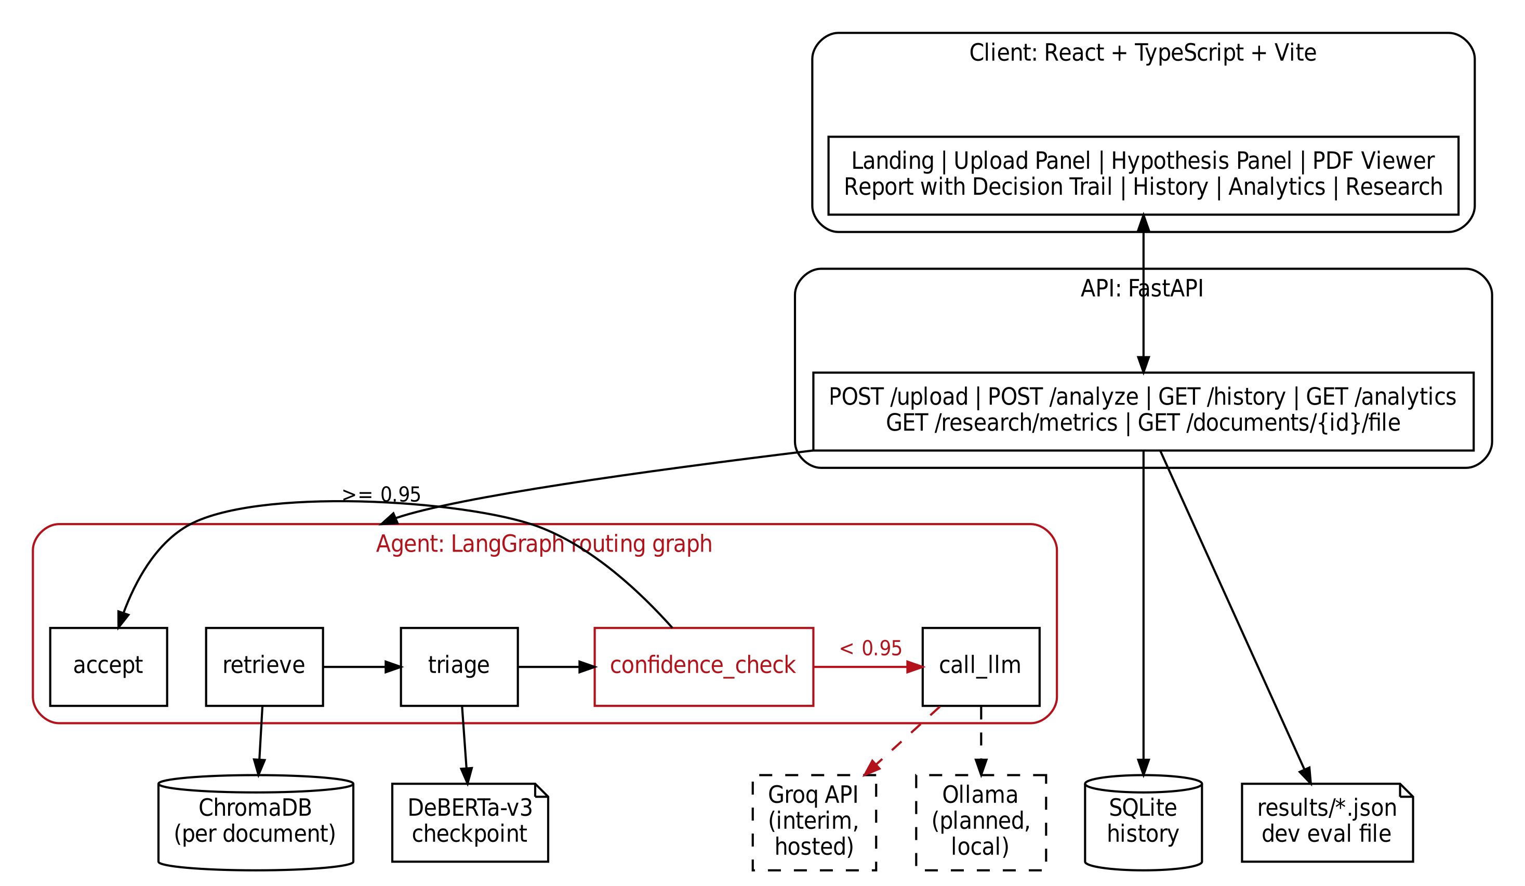
Fig 3.4.1 Architecture Diagram

3.4.2 Use Case Diagram
Figure 3.4.2 shows the actors and use cases. The reviewer uploads contracts, enters hypotheses, runs analyses and views results, history and analytics. The researcher views research metrics and runs experiments. Escalation to the LLM extends the analysis use case when the confidence is below the threshold, and involves the external LLM provider.
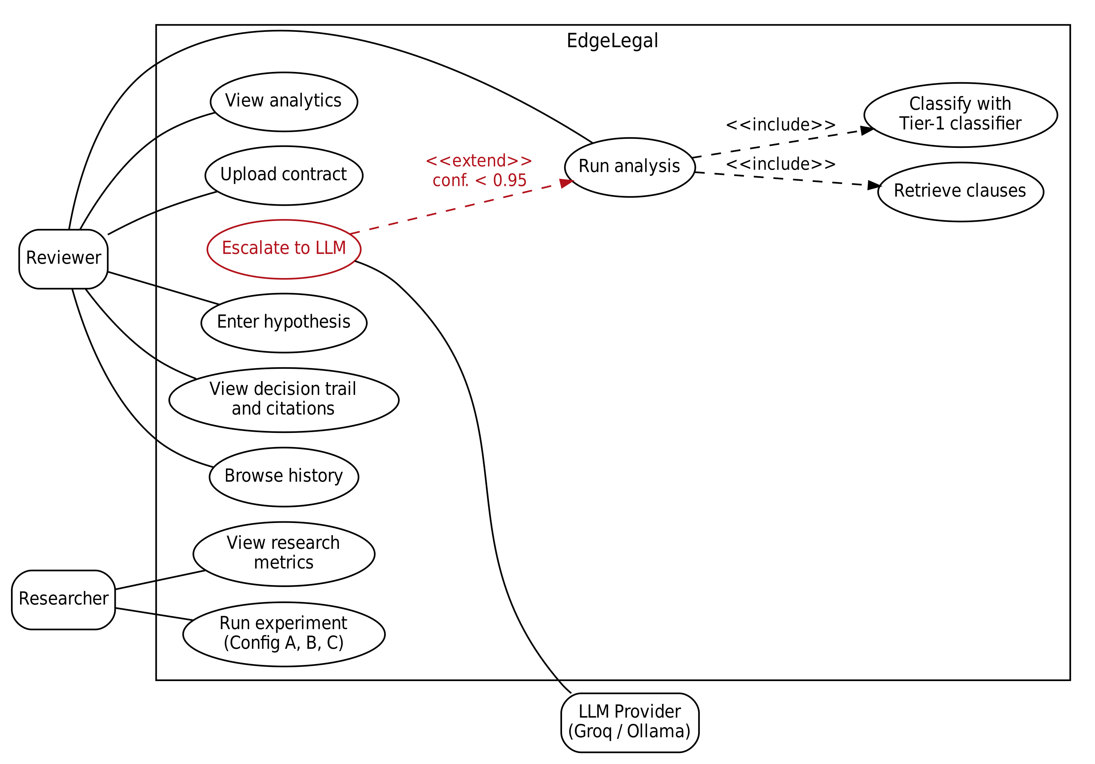
Fig 3.4.2 Use Case Diagram

3.4.3 Class Diagram
Figure 3.4.3(a) shows the pipeline classes: the agent graph reads and writes AgentState and uses the embedder, the classifier model and an LLM client, and Clause and PageBlock are the parsing outputs. Figure 3.4.3(b) shows the data structures of the API: ReportResult contains a TriageDetail and any number of ReportCitation objects, and ResearchMetrics contains one ConfigResult for each of the three configurations.
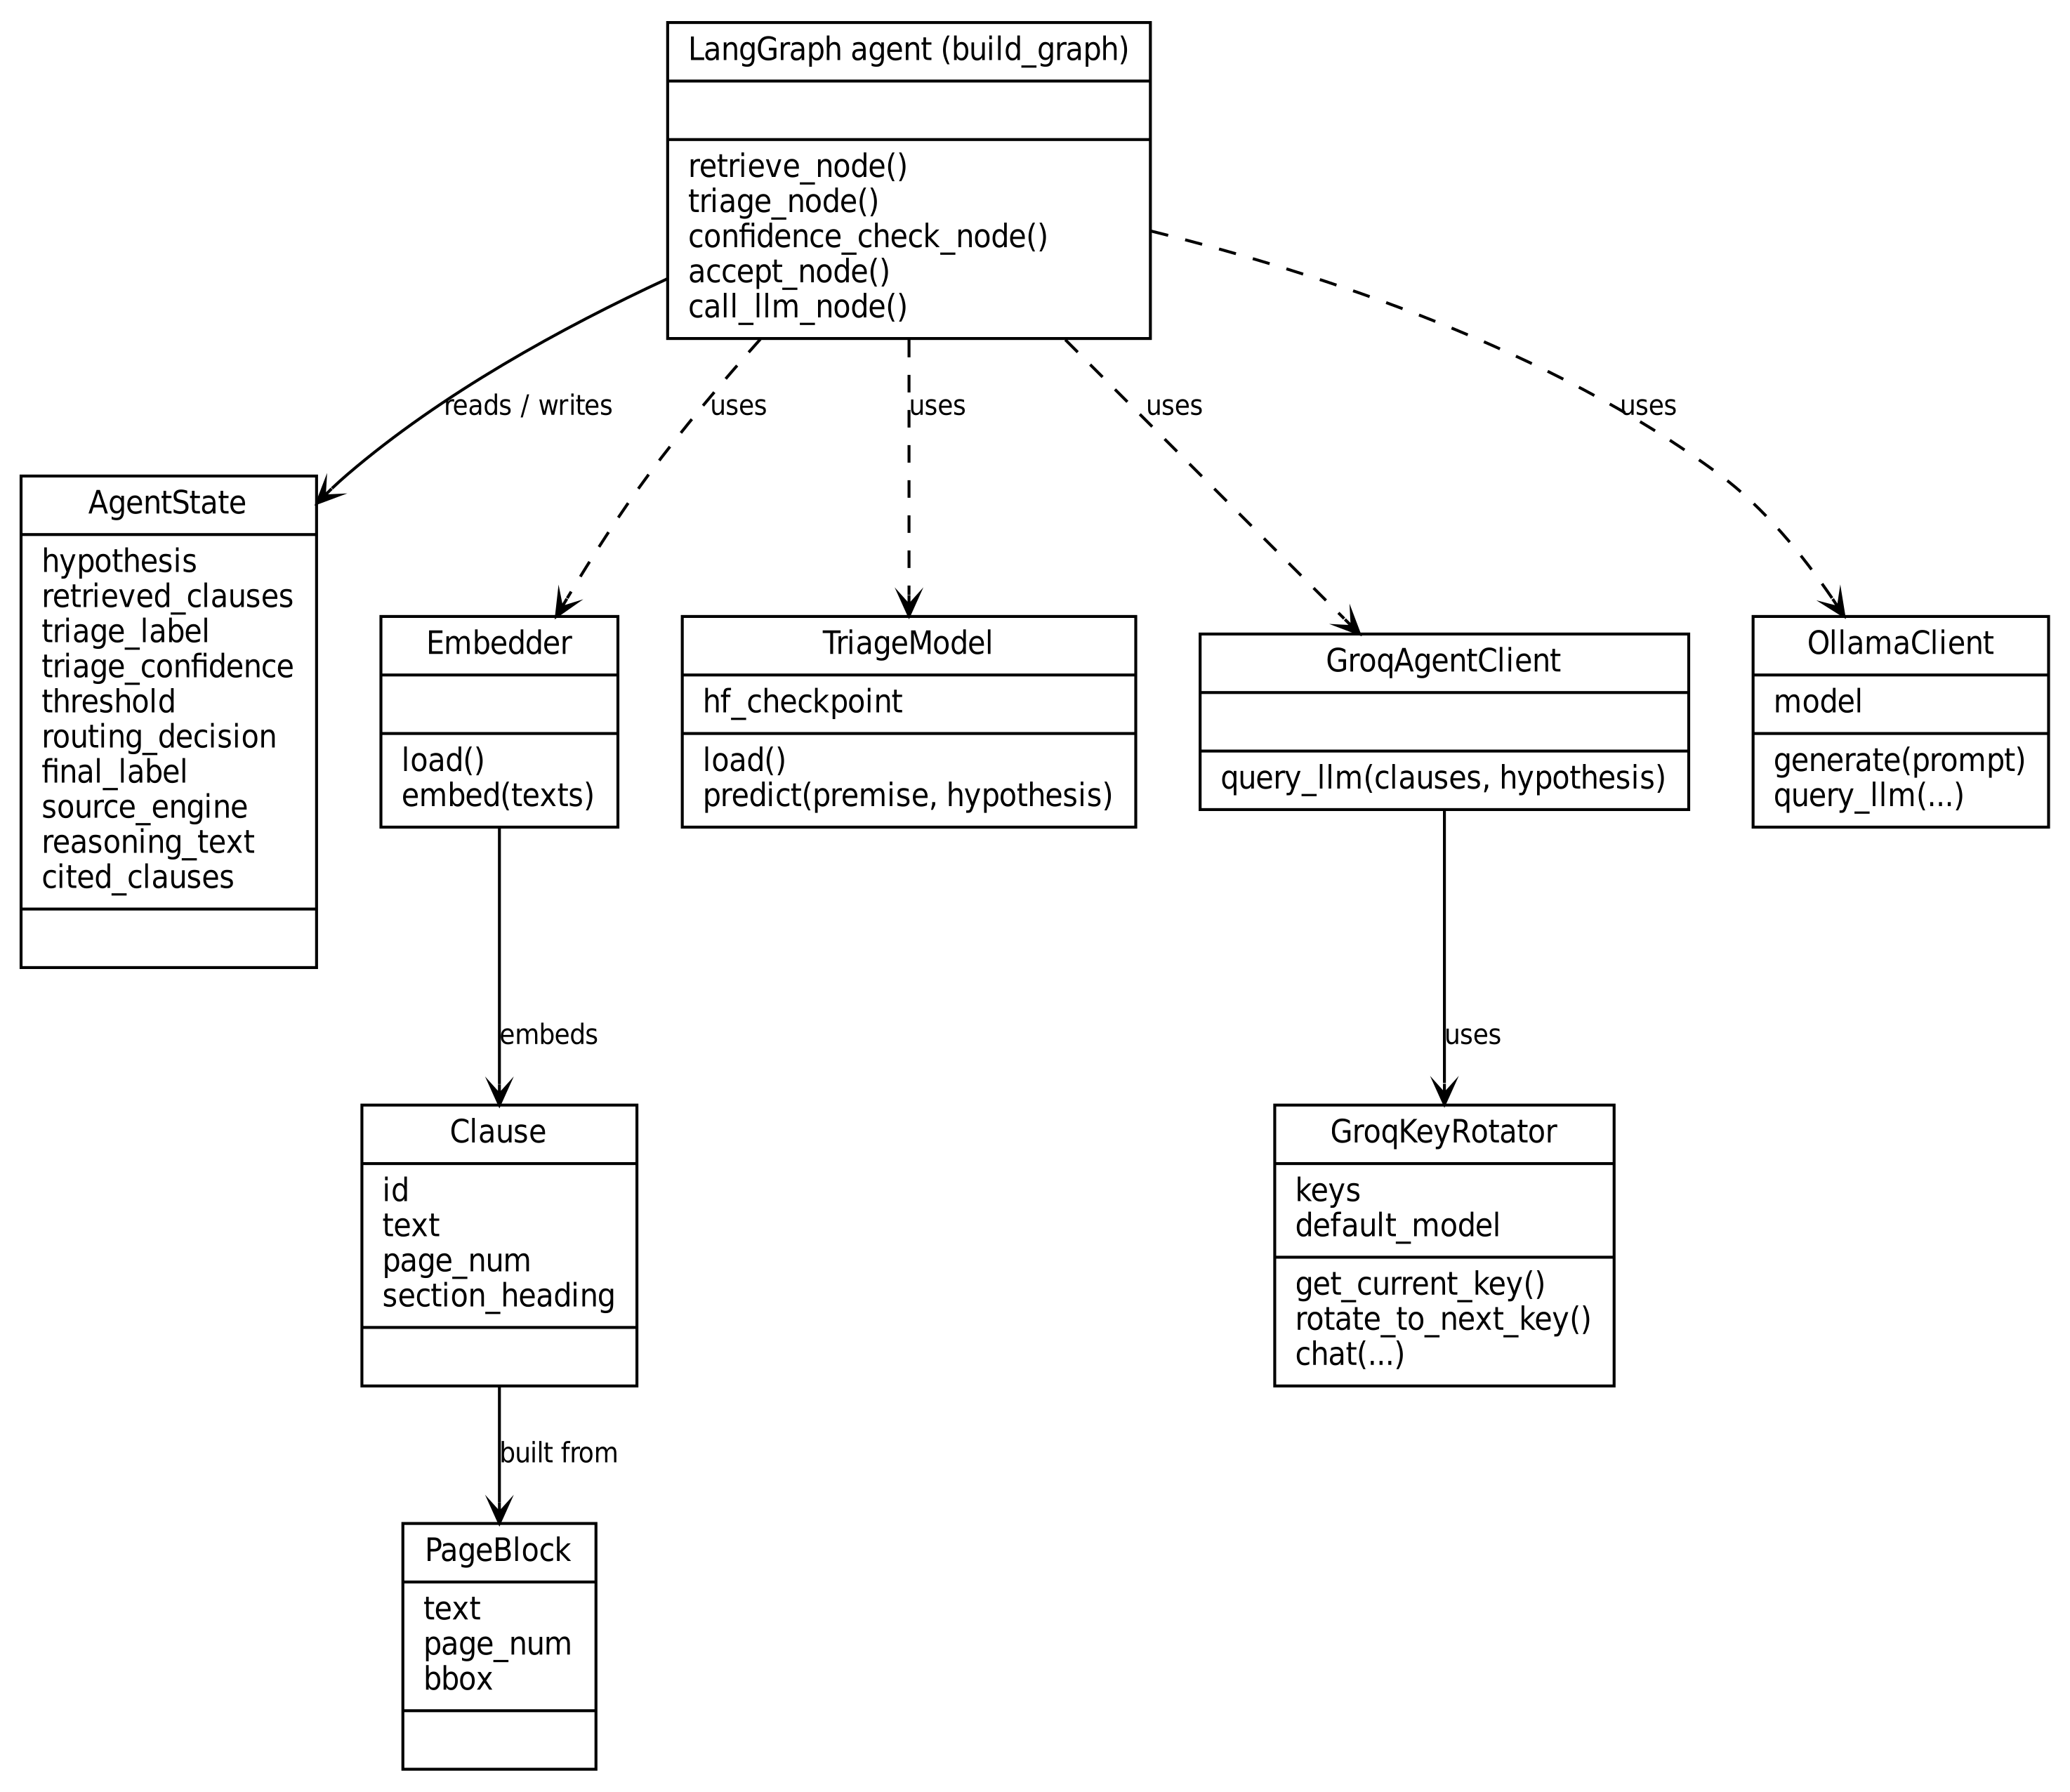
Fig 3.4.3(a) Class Diagram: Pipeline Classes
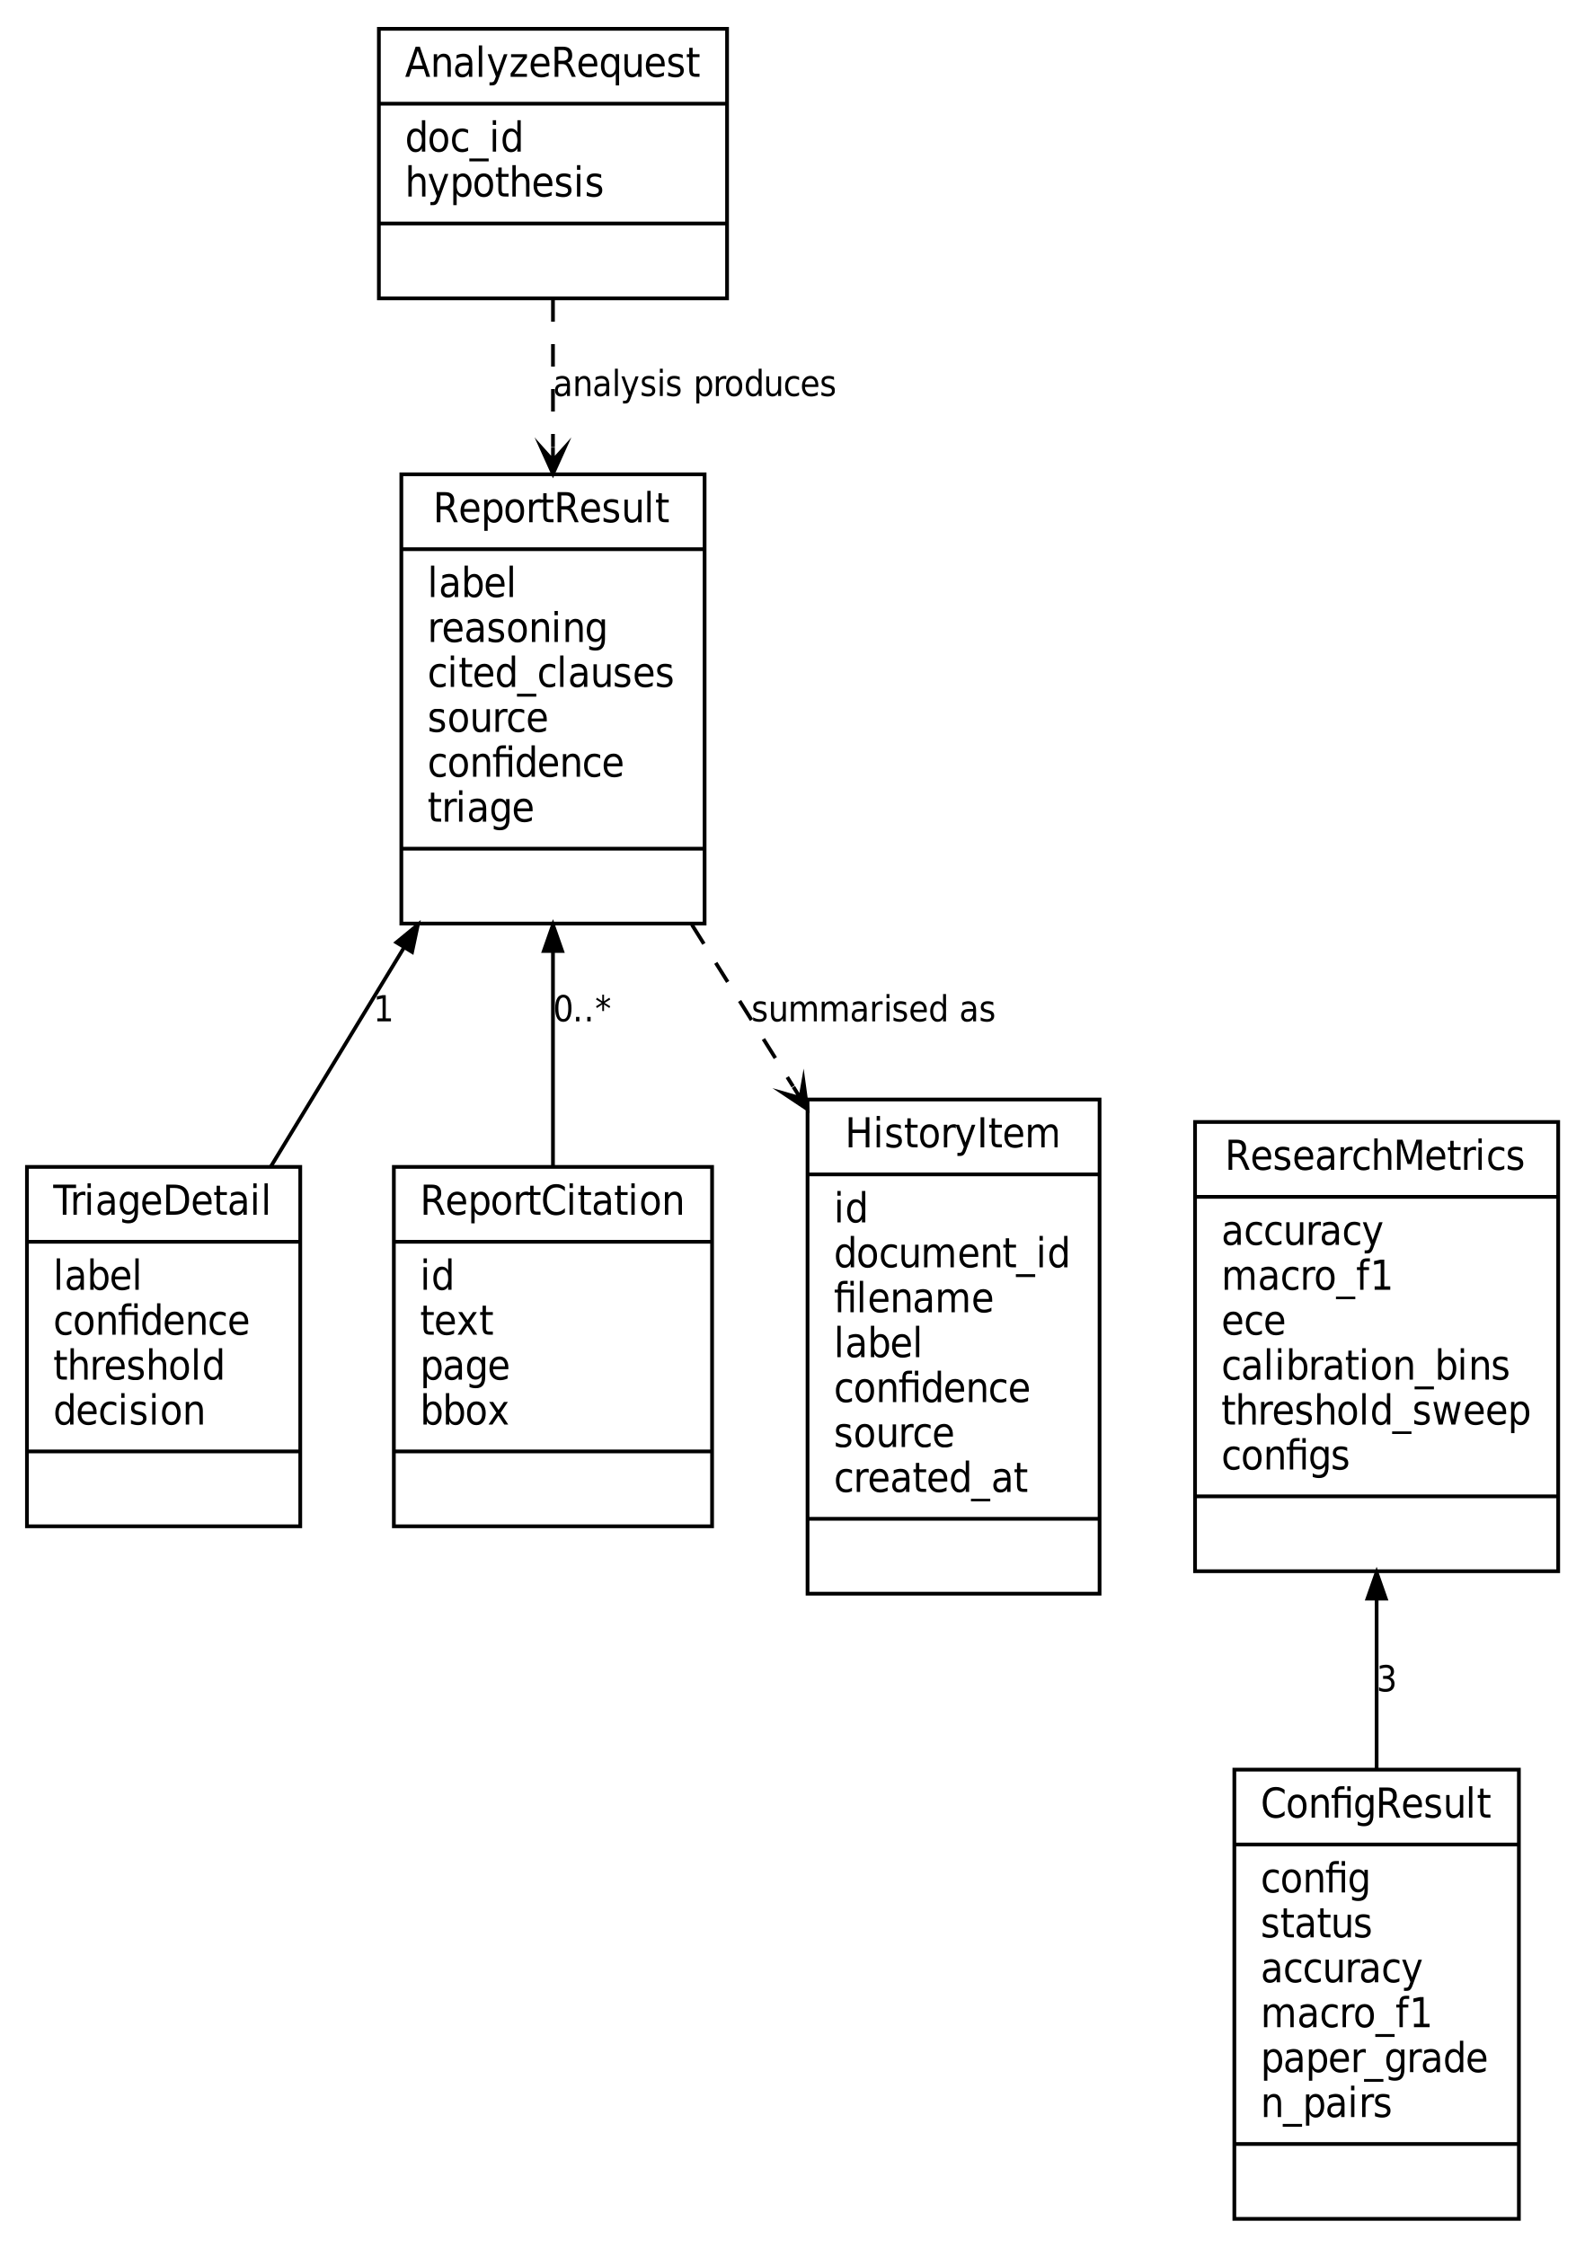
Fig 3.4.3(b) Class Diagram: Data Structures of the API

3.4.4 Sequence Diagrams
Figure 3.4.4(a) shows upload and indexing. The server checks the file type, saves the file, segments it into clauses, embeds them, stores them in ChromaDB and records the document in the history database before returning the document identifier.
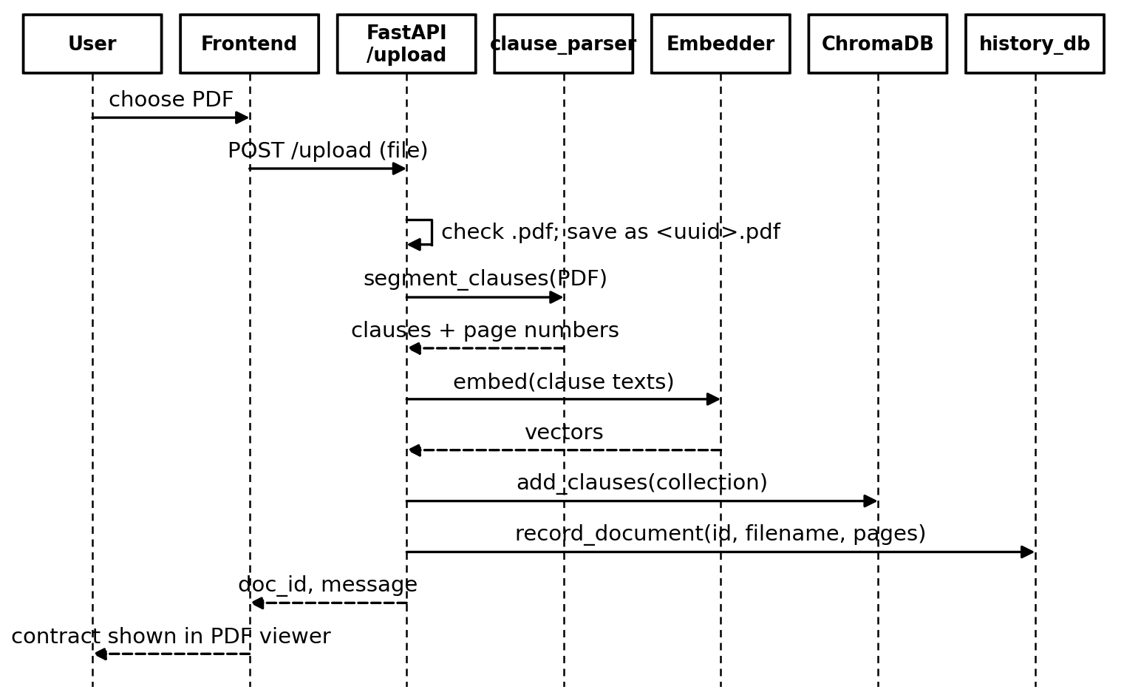
Fig 3.4.4(a) Sequence Diagram: Upload and Indexing
Figure 3.4.4(b) shows an analysis. The agent retrieves clauses with the gap filter, the classifier predicts a label and a confidence, and the confidence check either accepts the label or calls the LLM client. The server records the analysis and the front end shows the verdict with the decision trail.
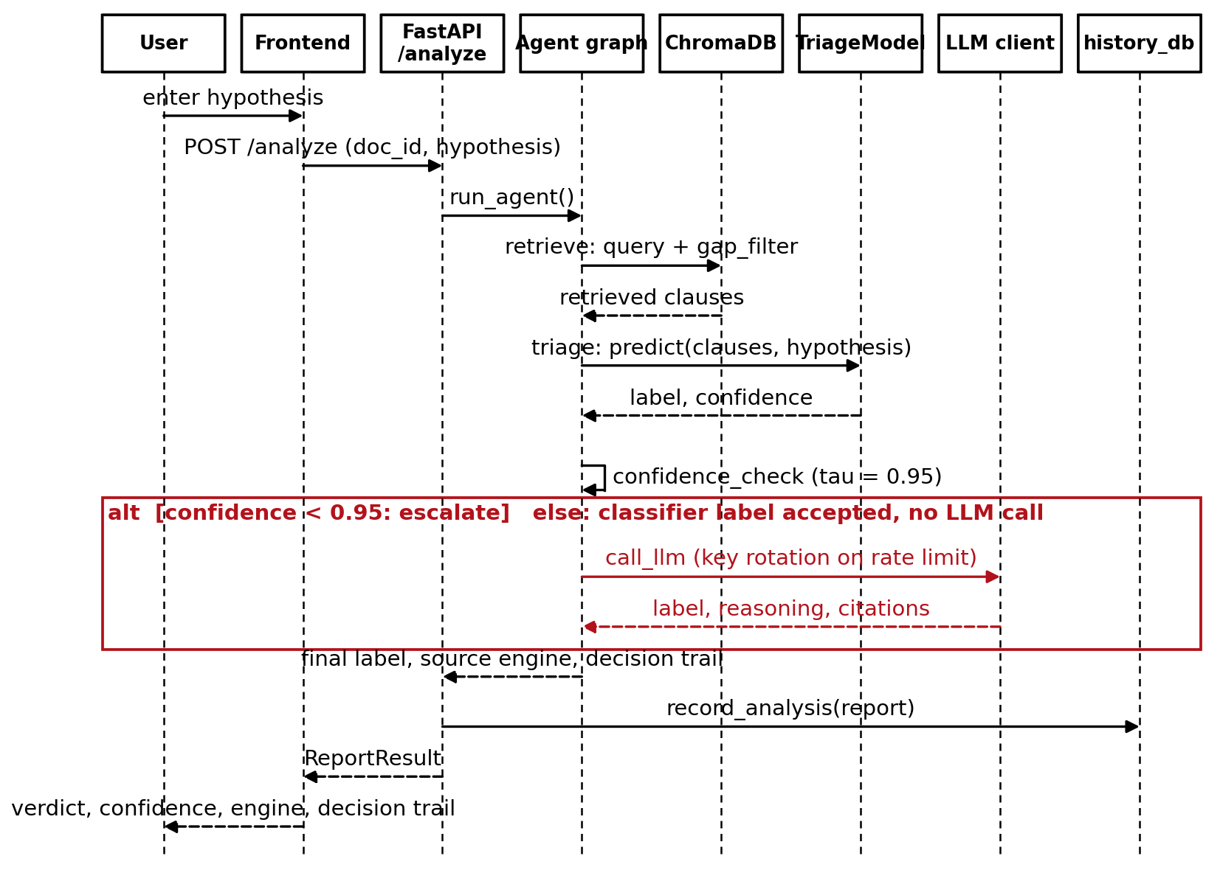
Fig 3.4.4(b) Sequence Diagram: Analysis with Triage and Escalation
Figure 3.4.4(c) shows an experiment run and the display of its results. The experiment runner writes one result file per configuration. The Research page asks the server for metrics, and the research module reads the newest file for each configuration together with the development evaluation file.
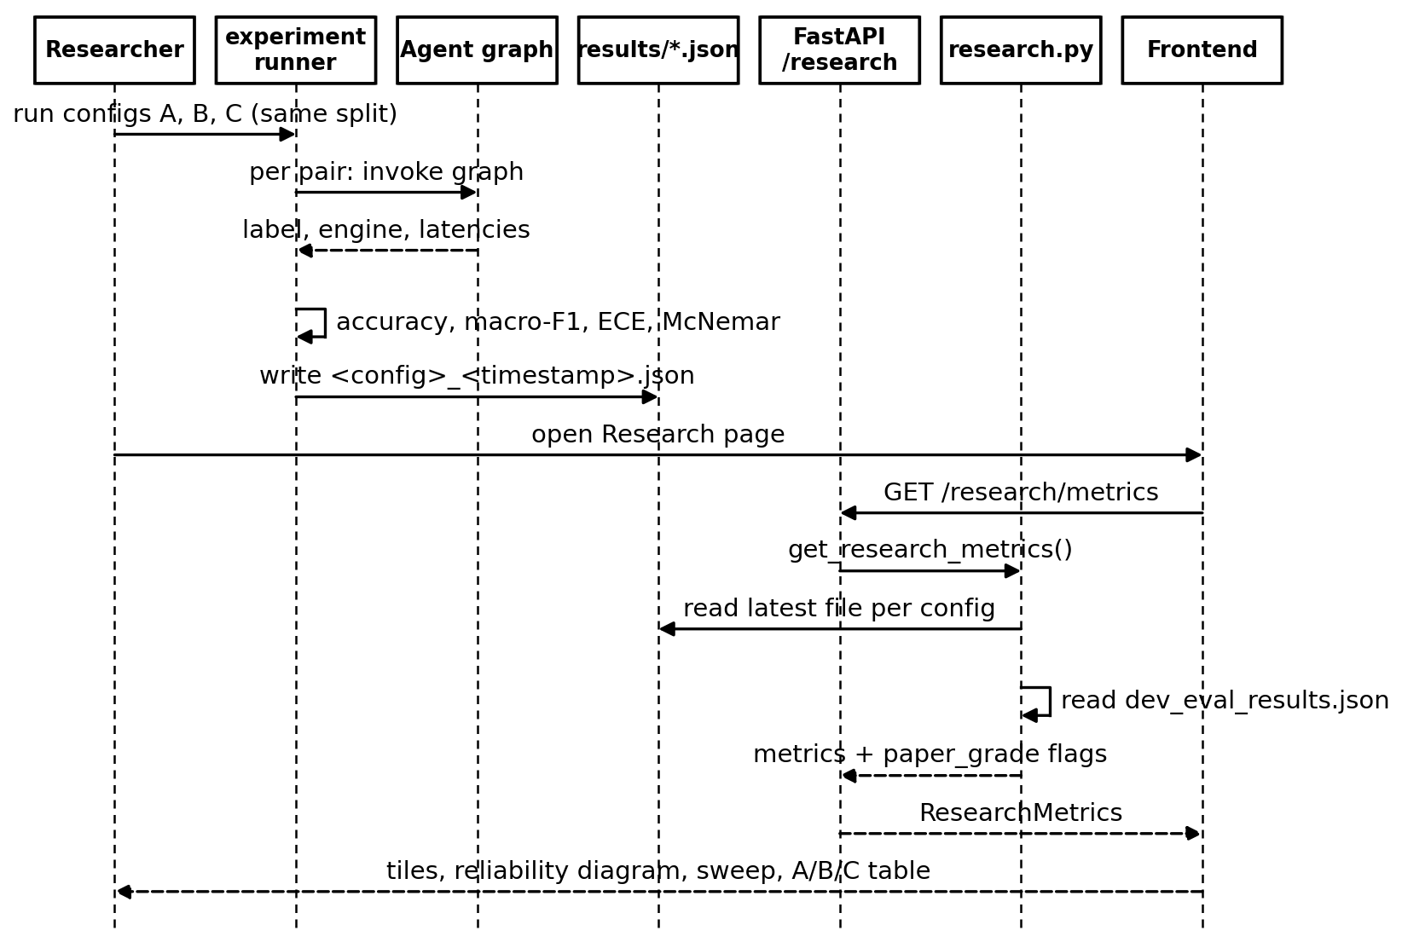
Fig 3.4.4(c) Sequence Diagram: Research Run and Results

3.4.5 ER Diagram
Figure 3.4.5 shows the two tables of the history database. A document has many analyses. Deleting a document deletes its analyses, and the two indexes support listing by time and filtering by document.
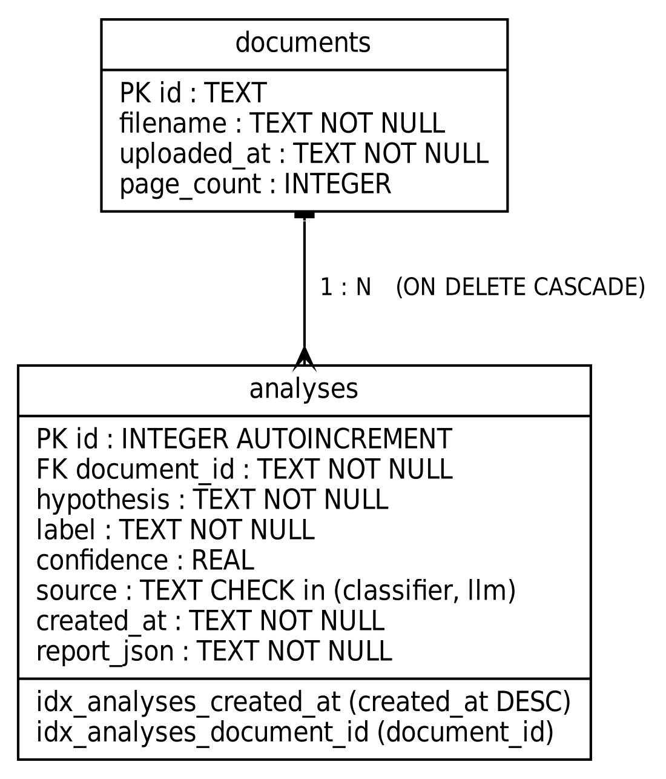
Fig 3.4.5 ER Diagram

3.4.6 Activity Diagram
Figure 3.4.6 shows the activity from upload to the stored result, with the decision on the confidence threshold.
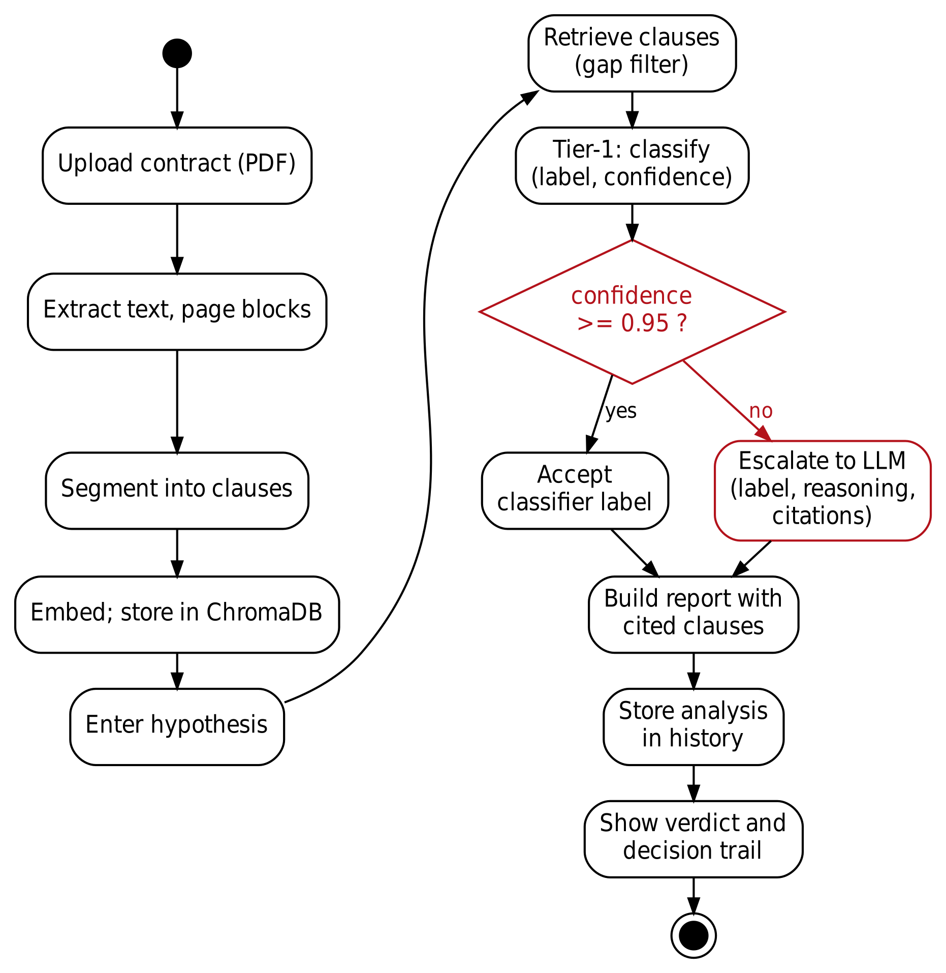
Fig 3.4.6 Activity Diagram

3.5 Summary
This chapter specified the purpose, scope, constraints and requirements of EdgeLegal and described its design with UML diagrams. The next chapter describes how each part is implemented.

4. METHODOLOGY

4.1 Modules
The system is divided into eight modules. Table 4.1.1 lists them with their main source files, and Table 4.1.2 lists the operations of the REST API.
Module 1: Training Pipeline
This module fine-tunes the classifier on ContractNLI. It loads the training and development splits, builds premise and hypothesis pairs, trains a DeBERTa-v3-base NLI cross-encoder with class-weighted cross-entropy, a linear warm-up schedule, gradient accumulation and early stopping on development macro-F1 with a patience of two epochs, and saves the best checkpoint. The label order is Contradiction = 0, Entailment = 1, NotMentioned = 2. Training was done on a Kaggle T4 GPU because the development laptops have no GPU.
Module 2: Document Parsing and Retrieval
This module extracts text and page blocks from a PDF, segments it into clauses that keep page numbers and section headings, embeds the clauses with bge-small-en and stores them in a ChromaDB collection for the document. At query time it returns the nearest clauses and applies the adaptive gap filter.
Module 3: Triage Classifier
This module wraps the fine-tuned checkpoint. Its predict function takes a premise and a hypothesis and returns the predicted label and the confidence, defined as the maximum softmax probability.
Module 4: Agent Graph
This module defines the LangGraph routing graph with the nodes retrieve, triage, confidence_check, accept and call_llm. Config A skips the triage step and sends every case to the LLM.
Module 5: LLM Provider
This module contains the Groq client with API-key rotation and retries on rate limits, the local Ollama client, and the prompts. The prompt contains the hypothesis and several retrieved clauses and asks for a JSON answer with a label, reasoning and cited clauses. The parser tolerates minor formatting errors in the model output.
Module 6: API and Service
This module exposes the REST API with FastAPI, runs the agent for live requests, stores history in SQLite, serves research metrics, validates requests and responses with Pydantic schemas, and configures logging.
Module 7: Experiment and Analysis
This module contains the experiment runner for Configs A, B and C, the retrieval inclusion test, and the recalibration study.
Module 8: Front End
This module is the React and TypeScript application with the Landing, App, History, Analytics and Research pages, and components such as the upload panel, hypothesis panel, PDF viewer, report panel with the decision trail, and statistic tiles.
Table 4.1.1 – Modules and Their Main Source Files
No. | Module | Main source files (under backend/app unless noted)
1 | Training Pipeline | triage_model/train.py, dataset.py, evaluate.py, verify_checkpoint.py
2 | Parsing and Retrieval | parsing/clause_parser.py, embeddings/embedder.py, vectorstore/chroma_client.py
3 | Triage Classifier | triage_model/model.py, infer.py
4 | Agent Graph | agent/graph.py, nodes.py, state.py
5 | LLM Provider | llm/groq_client.py, ollama_client.py, prompts.py
6 | API and Service | main.py, agent/live_service.py, history_db.py, research.py, schemas.py, logging_config.py
7 | Experiment and Analysis | experiment_runner.py, retrieval_accuracy_check.py, recalibration_preview.py
8 | Front End | frontend/src/pages/*, components (UploadPanel, HypothesisPanel, PDFViewer, ReportPanel, StatTile, AppHeader)

Table 4.1.2 – REST API Operations
Method | Endpoint | Purpose | Main response fields
GET | /health | Liveness check | status
POST | /upload | Upload, parse and index a PDF | doc_id, message
POST | /analyze | Analyse a hypothesis against a document | label, reasoning, cited_clauses, source, confidence, triage
GET | /history | List analyses with filters, search and pagination | items, total, limit, offset
GET | /history/documents | List analysed documents | id, filename, analysis_count
GET | /history/{analysis_id} | Reopen a saved analysis | full report
GET | /analytics | Usage statistics | totals, contradiction_rate, top_hypotheses
GET | /research/metrics | Evaluation data for the Research page | accuracy, ece, bins, sweep, configs
GET | /documents/{doc_id}/file | Return the original PDF | PDF file

4.2 Methodology Proposed for Solution Implementation
The solution was implemented in nine steps.
- Requirement analysis and literature survey, ending in the gap analysis of Section 2.3.
- Design of the architecture, the routing graph and the experiment plan.
- Data setup: downloading ContractNLI and preparing the train, dev and test splits.
- Fine-tuning the classifier on Kaggle and verifying the checkpoint on the development split.
- Building the retrieval layer: parsing, embedding, storage and the gap filter.
- Building the confidence-routed graph.
- Building the LLM tier with key rotation and a local-model client.
- Building the web application and the history store.
- Running experiments, calibration checks and tests, and recording the results.
Figure 4.2.1 shows the workflow and the artefact produced at each step.
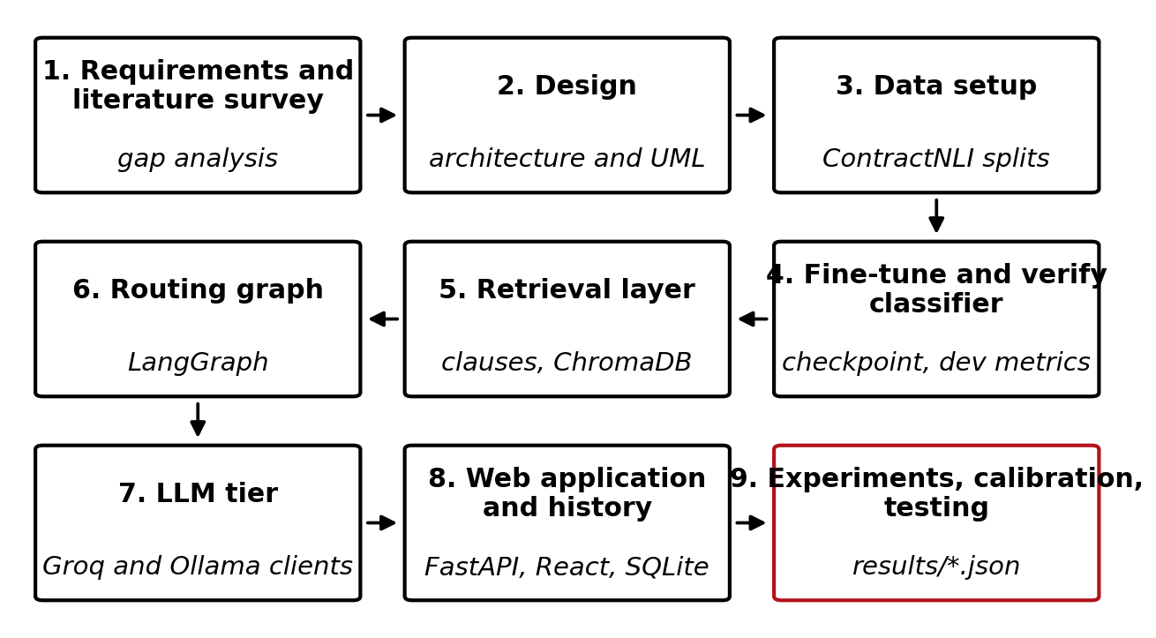
Fig 4.2.1 Overall Workflow of the System

4.2.1 Data and Preprocessing
ContractNLI contains 607 contracts and 17 hypotheses with 423 training, 61 development and 123 test contracts [1]. Each contract and hypothesis pair carries a label and the annotated evidence spans. The development split used for classifier evaluation has 1,037 examples (519 Entailment, 423 NotMentioned and 95 Contradiction). The fine-tuning pairs are built from the evidence annotations. This choice has a consequence discussed in Section 5.3.2: the classifier is trained on annotated evidence but receives retrieved clauses when it is used in the live pipeline.

4.2.2 Clause Segmentation, Embedding and Retrieval
The PDF text is split into clauses using the document's structure, and each clause keeps its page number and section heading. Clauses are embedded with BAAI/bge-small-en [20] and stored in a ChromaDB collection created for the document. For a hypothesis, the nearest clauses by cosine distance are returned in rank order and filtered with the adaptive gap filter. The filter always keeps the top-ranked clause and keeps each following clause only while its distance is at most 1.15 times the distance of the top clause. It stops at the first clause above that ceiling. Because the ceiling is fixed to the top clause, a long run of small increases cannot drift past the relevance band. Figure 4.2.2 illustrates the rule with the example from the source code; the values are an illustration and not a measured query.
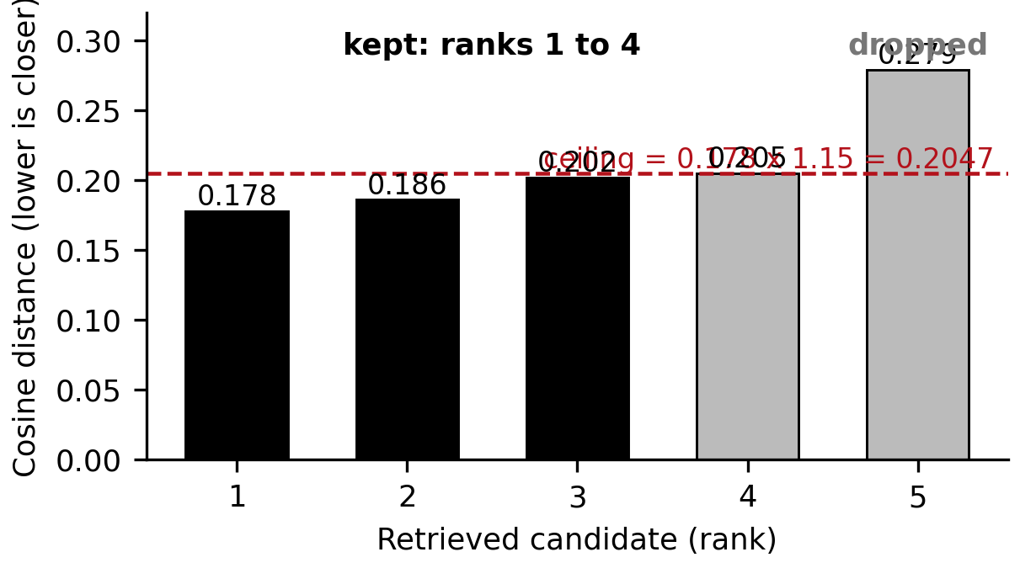
Fig 4.2.2 Retrieval and Gap Filter (illustration)

4.2.3 Fine-Tuning the Triage Classifier
The classifier is the cross-encoder/nli-deberta-v3-base checkpoint, which already has a three-way entailment head, fine-tuned on the ContractNLI training pairs. Table 4.2.1 lists the main parameters. The best checkpoint by development macro-F1 is kept. At inference the model reads the premise and the hypothesis together and returns the softmax probabilities over the three labels; the label is the highest-probability class and the confidence is that probability.
Table 4.2.1 – Main Parameters
Parameter | Value
Classifier checkpoint | cross-encoder/nli-deberta-v3-base, fine-tuned on ContractNLI
Epochs | Up to 3, with early stopping on development macro-F1 (patience 2)
Batch size | 32 (training script setting; default 8 with gradient accumulation 4)
Learning rate | 2e-5, linear warm-up (ratio 0.06), weight decay 0.01
Loss | Class-weighted cross-entropy
Maximum sequence length | 512 at inference; training script default 384 (value used on Kaggle to be confirmed)
Confidence threshold | 0.95, chosen on the development split and frozen
Gap-filter ceiling | 1.15 times the distance of the top-ranked clause (15%)
Embedding model | BAAI/bge-small-en
LLM (interim) | openai/gpt-oss-20b on Groq, temperature 0
LLM (planned) | Local model through Ollama (client default llama3.1:8b)

4.2.4 Confidence, Threshold Selection and Routing
The threshold was selected on the development split only. Confidence thresholds from 0.60 to 0.95 in steps of 0.05 were swept, and for each the share of cases accepted (coverage) and the macro-F1 on the accepted cases were recorded. The best macro-F1 was at 0.95, and that value was frozen before any test data was used. The routing rule is shown below and in Figure 4.2.3.
confidence = max(softmax(classifier(premise, hypothesis)))
if confidence >= 0.95:
final_label = classifier_label ; source = 'classifier'
else:
final_label, reasoning, citations = LLM(hypothesis, clauses)
source = 'llm'
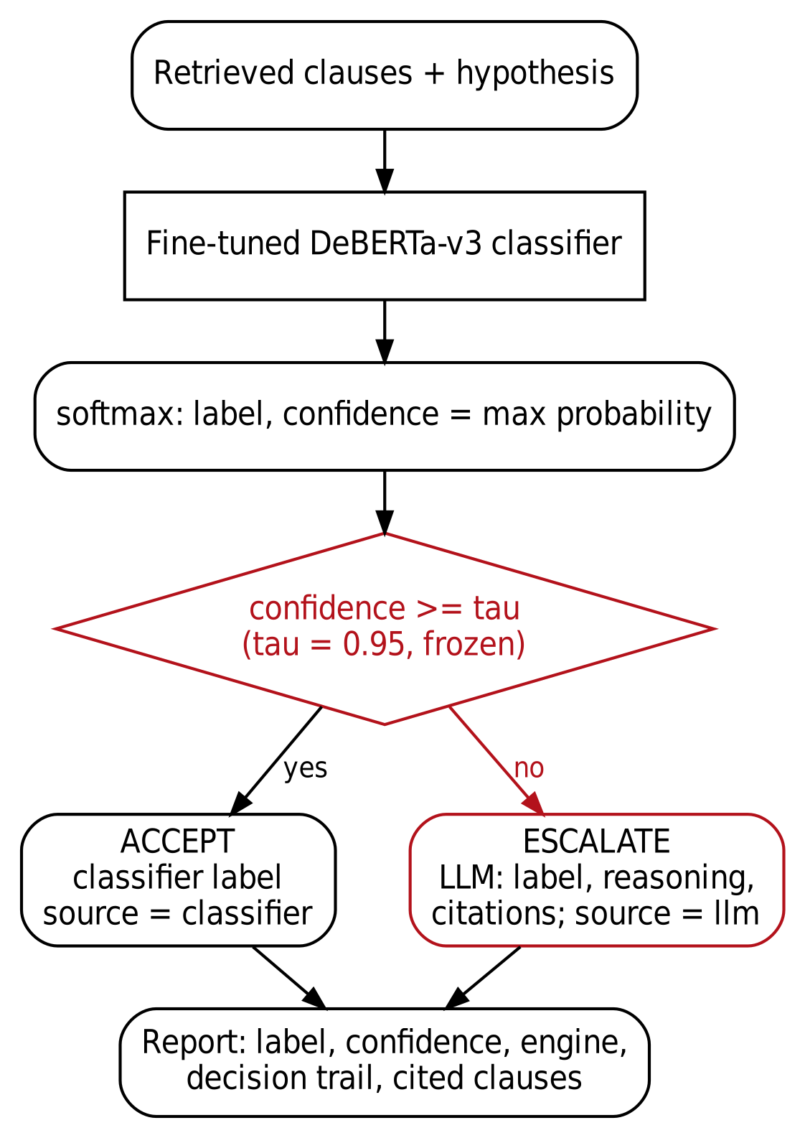
Fig 4.2.3 Confidence Routing Logic

4.2.5 LLM Escalation and Prompting
An escalated case is sent to the LLM with the hypothesis and the retrieved clauses, and the model is asked to return a label, a reasoning text and the clauses it used, as JSON. The interim provider is the openai/gpt-oss-20b model [21] on Groq, called with temperature 0. The client rotates through several API keys and waits and retries when a rate-limit error is returned. A local Ollama client is implemented for the final configuration so that no contract text leaves the machine.

4.2.6 Experimental Configurations and Metrics
Three configurations are compared on the same pairs and with the same threshold (Figure 4.2.4). Config A retrieves clauses and sends every pair to the LLM. Config B uses the off-the-shelf NLI model as the gate. Config C uses the fine-tuned model as the gate. For each run the runner records the metrics in Table 4.2.2 and writes a result file that includes the language-model provider and a flag that marks whether the run is paper-grade. Runs that use the hosted LLM are never marked paper-grade.
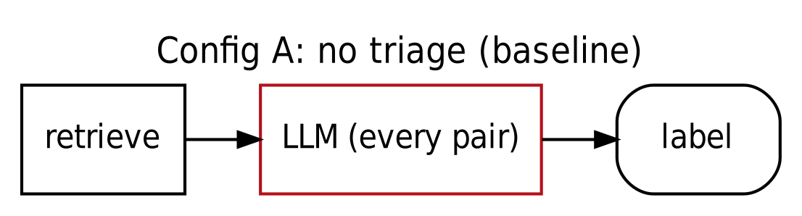
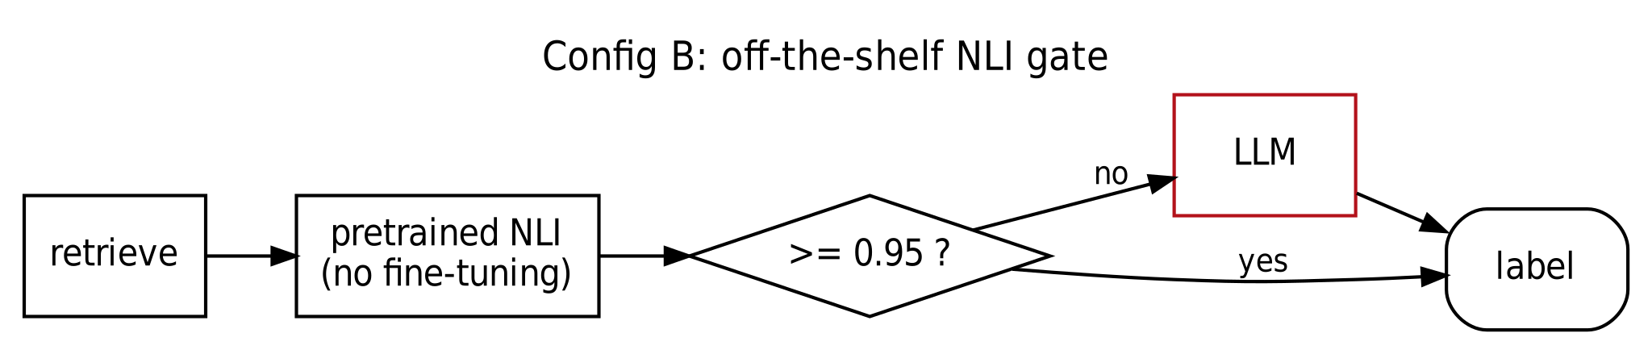
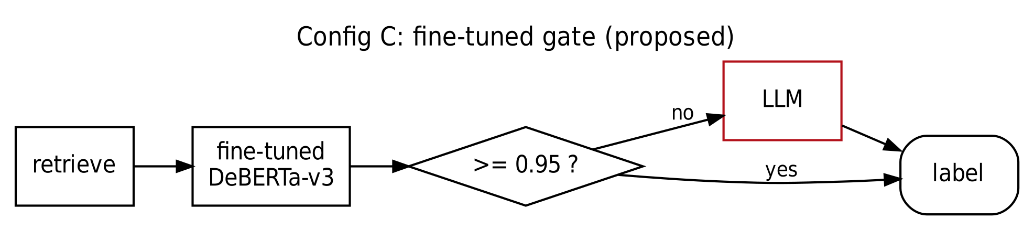
Fig 4.2.4 Experimental Configurations
Table 4.2.2 – Evaluation Metrics
Metric | Meaning
Accuracy, macro-F1 | Correctness of the final label, with macro-F1 averaging the F1 of the three classes equally.
Coverage / no-LLM rate | Share of cases accepted by the classifier without calling the LLM.
ECE (10 bins) | Sum over equal-width confidence bins of the share of cases in the bin times the absolute gap between bin accuracy and bin confidence.
Reliability diagram | Bin accuracy plotted against bin confidence; points on the diagonal mean perfect calibration.
AUROC of confidence | How well confidence separates correct from wrong answers (0.5 is chance).
Latency | Mean, standard deviation, median and 95th percentile of time per pair, by engine.
McNemar test | Paired, continuity-corrected chi-square test on the pairs where two configurations disagree [19].

4.2.7 Data Storage and Analytics
Every document and every analysis is stored in an SQLite database (Table 4.2.3, Figure 3.4.5). The analytics page is computed from this database by SQL aggregates, and the Research page is computed from the saved evaluation and result files.
Table 4.2.3 – Database Tables
Table | Columns
documents | id (primary key), filename, uploaded_at, page_count
analyses | id (primary key), document_id (foreign key, cascade delete), hypothesis, label, confidence, source (classifier or llm), created_at, report_json; indexes on created_at and document_id

4.3 Summary
This chapter described the modules, the implementation steps, the retrieval and routing methods and the experimental design. The next chapter reports the tests and results.

5. TESTING & RESULTS
This chapter reports only checks and measurements that were actually run. Sections 5.1 and 5.2 describe automated checks executed on 2 October 2026. Section 5.3 reports the evaluation of the classifier, the pipeline and retrieval, taken from the saved result files in the repository. Items that have not been carried out are named as such.

5.1 Unit Testing
Test Case Number | 1
Type of Testing | Unit testing (automated script)
Component Being Tested | History database, confidence routing, gap filter, ECE, McNemar test, label order
Date of Testing | 2 October 2026
Tester | Project team (scripted run)
Testing Phase | Implementation complete; before submission

The repository did not contain an automated test suite at the time of writing. The checks in Table 5.1 were therefore written as a script and run against a copy of the back-end code. The script is not part of the repository. The history database checks ran against a real SQLite file in a temporary location. The routing, gap-filter, calibration and significance functions were called directly. The PyTorch, ChromaDB and language-model packages were replaced by stubs, because they were not installed in the test environment, so these checks cover the logic of the functions and not model inference.
Table 5.1 – Unit Test Cases and Results
ID | Check | Expected and actual result | Result
U1 | init_db creates tables and indexes | documents, analyses and both indexes exist | Pass
U2 | Record and fetch an analysis | Round trip returns the stored report; unknown id returns None | Pass
U3 | Label and document filters | Contradiction filter returns 1 row; document filter returns 3 | Pass
U4 | Search escapes % and _ | A literal % or _ matches only rows that contain it; no match returns 0 | Pass
U5 | Pagination | Two pages of 2 are disjoint and the total is 4 | Pass
U6 | since filter | Naive and offset ISO timestamps accepted; a future time returns 0 rows | Pass
U7 | Invalid since value | ValueError raised | Pass
U8 | Unknown engine name | Database rejects the row (IntegrityError) | Pass
U9 | Analysis for an unknown document | Document row created with a placeholder filename | Pass
U10 | Analytics on 5 known rows | Contradiction rate 0.2; 4 classifier and 1 LLM analyses | Pass
U11 | Analytics on an empty database | All zeros, average confidence None, no error | Pass
U12 | Cascade delete | Deleting a document removes its analyses | Pass
U13 | Routing around the threshold | 0.0 and 0.9499 escalate; 0.95, 0.9501 and 1.0 accept | Pass
U14 | Gap filter anchored to rank 1 | Ceiling is 1.15 times the top distance; a chain of small steps cannot pass it; one candidate is kept | Pass
U15 | ECE on hand-built inputs | Perfect case 0.0; confidence 0.99 with 50% accuracy gives 0.49; empty input gives 0.0 | Pass
U16 | McNemar on hand-built pairs | b = c = 6 gives statistic 0.0833, p = 0.7728; b = 16, c = 0 gives 14.06, p = 1.8e-4; identical results give p = 1; different pair sets raise ValueError | Pass
U17 | Label order in the dataset module | Contradiction 0, Entailment 1, NotMentioned 2 | Pass

All 17 unit checks passed. They do not test the classifier, the embedding model or the LLM, and the pipeline's accuracy is therefore reported separately in Section 5.3.

5.2 System Testing
Test Case Number | 2
Type of Testing | System testing (API level, automated script)
Component Being Tested | FastAPI endpoints with the model stack stubbed
Date of Testing | 2 October 2026
Tester | Project team (scripted run)
Testing Phase | Implementation complete; before submission

The API was exercised through the FastAPI test client with the clause indexing and the agent replaced by stubs that return fixed values and with a temporary history database. The research endpoint was not stubbed: it read the real development evaluation file and result files of the repository. The checks therefore test request validation, routing, history, error handling and the reading of result files, and not the analysis itself.
Table 5.2 – API System Tests
ID | Check | Expected and actual result | Result
S1 | GET /health | 200 with status ok | Pass
S2 | POST /upload with a .txt file | 400, only PDF files are supported | Pass
S3 | POST /upload with a PDF | 200 with a document id (indexing stubbed to 12 clauses) | Pass
S4 | GET /documents/{id}/file | 200 and application/pdf for the stored file | Pass
S5 | File endpoint with a traversal string, a non-UUID and an unknown UUID | 404 for all three | Pass
S6 | POST /analyze | 200 with the stubbed report (Contradiction, classifier) | Pass
S7 | POST /analyze error handling | Agent failure returns 500 with detail; a missing field returns 422 | Pass
S8 | GET /history filters | Label filter returns matching rows; invalid label, invalid since and limit 0 return 422 | Pass
S9 | GET /history/documents and /history/{id} | Document listed; item returns 200; unknown id returns 404 | Pass
S10 | GET /analytics | Totals and rate within valid ranges | Pass
S11 | Empty database through the API | Zero totals and an empty history list with status 200 | Pass
S12 | GET /research/metrics | Reads the real files: 1,037 examples, accuracy 0.9701, ECE 0.0285; three configurations present, none marked paper-grade | Pass
S13 | CORS preflight | 200 | Pass

All 13 system checks passed. End-to-end analysis through the real classifier, the embedding model, ChromaDB and an LLM was exercised by the experiment runs and the live application (Sections 5.3 and 5.4), not by this script.

5.3 Classifier Accuracy, Calibration and Retrieval Tests

5.3.1 Dev-Split Evaluation
The fine-tuned classifier was evaluated on the 1,037 examples of the ContractNLI development split, with the annotated evidence as the premise. The results are in Table 5.3. The classifier is accurate on all classes, with the Contradiction class the weakest (F1 0.848), and it is well calibrated (ECE 0.0285). Figure 5.3.1 shows the reliability diagram: almost all examples (1,027) fall in the highest-confidence bin, where accuracy is 0.973. Figure 5.3.2 shows the threshold sweep that led to the frozen threshold of 0.95. At that threshold 98.4% of cases are accepted and the macro-F1 on the accepted cases is 0.9511.
Table 5.3 – Dev-Split Results of the Fine-Tuned Classifier
Quantity | Precision | Recall | F1 | Support
Entailment | 0.9784 | 0.9615 | 0.9699 | 519
NotMentioned | 0.9976 | 1.0000 | 0.9988 | 423
Contradiction | 0.8155 | 0.8842 | 0.8485 | 95
Macro average | 0.9305 | 0.9486 | 0.9391 | 1,037
Accuracy |  |  | 0.9701 | 1,037
ECE (10 bins) |  |  | 0.0285
At tau = 0.95: coverage, macro-F1 of accepted |  |  | 98.4%, 0.9511 | 1,020 accepted

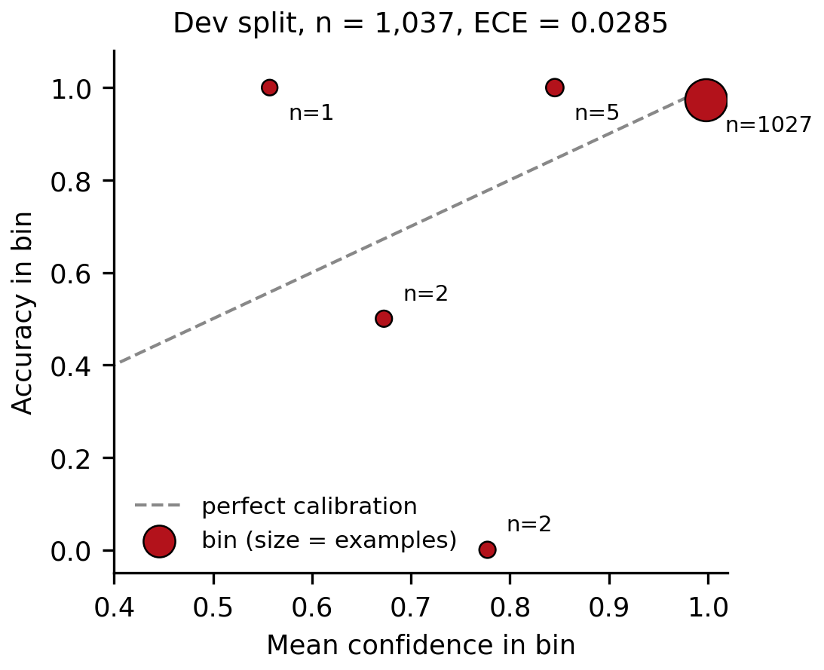
Fig 5.3.1 Reliability Diagram on the Dev Split
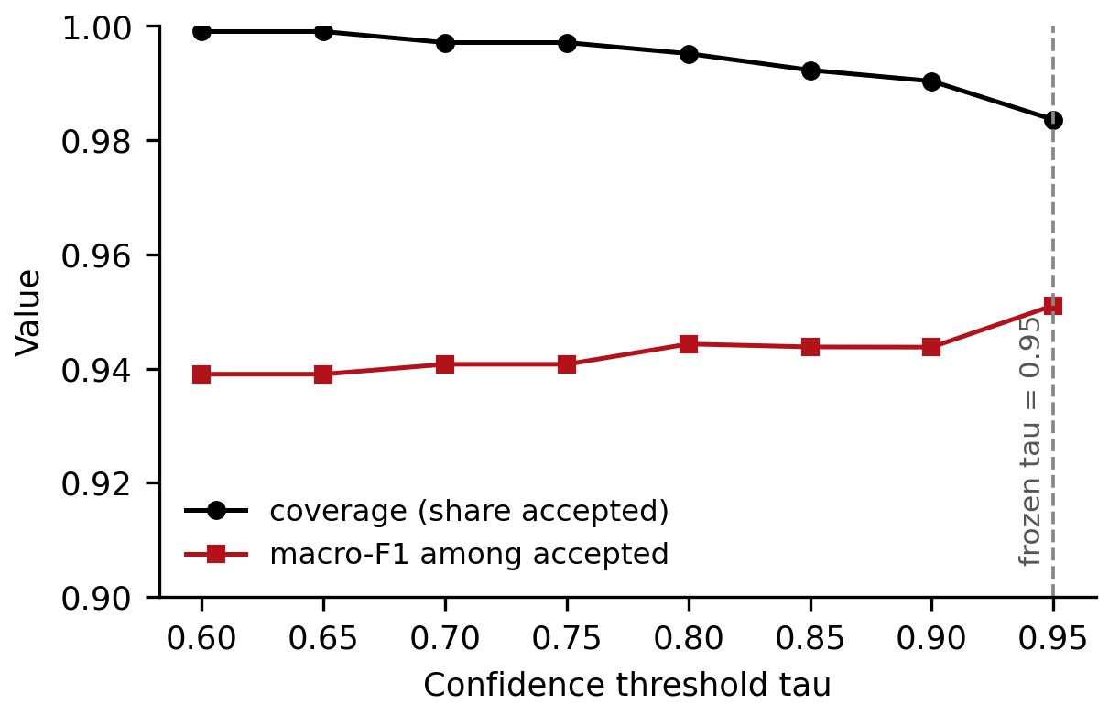
Fig 5.3.2 Threshold Sweep: Coverage and Macro-F1 versus Threshold

5.3.2 In-Pipeline Evaluation
The same classifier was then run inside the pipeline on 20 test documents (340 pairs), receiving retrieved clauses instead of annotated evidence (Config C, interim Groq LLM, not paper-grade). Table 5.4 compares the two settings and Figure 5.3.3 shows them as bars. Accuracy falls from 0.9701 to 0.5324, macro-F1 from 0.9391 to 0.4796, and ECE rises from 0.0285 to 0.4396. The classifier accepted 89.1% of cases (303 of 340 pairs were resolved by it and 37 were escalated); 309 of the 340 pairs fall in the highest-confidence bin, with an average confidence of about 0.994 but an accuracy of only about 55%, and the accuracy on the 303 accepted pairs was 55.1%. The 37 cases that were escalated were answered correctly 37.8% of the time. The confidence gate therefore does not separate right from wrong in this setting.
Two causes are identified. First, the classifier is trained on annotated evidence, but in the pipeline it receives retrieved clauses, which differ in length, content and boundaries; for NotMentioned pairs the training premise is the full document text, whereas the pipeline supplies only a few retrieved clauses. Second, retrieval misses the evidence in a quarter of the cases (Section 5.3.3), so even a perfect classifier could not answer them. The first cause is a distribution shift that the confidence does not detect; the model remains confident on inputs unlike those it was trained on.
Table 5.4 – Dev Split versus In-Pipeline Results
Quantity | Dev split (annotated evidence) | In pipeline (retrieved clauses)
Examples | 1,037 | 340 pairs (20 documents)
Accuracy | 0.9701 | 0.5324
Macro-F1 | 0.9391 | 0.4796
ECE (10 bins) | 0.0285 | 0.4396
Share accepted by the classifier at 0.95 | 98.4% | 89.1%
Accuracy on classifier-accepted cases | 0.9765 | 0.5512
Accuracy on LLM-escalated cases | not applicable | 0.3784 (37 pairs)

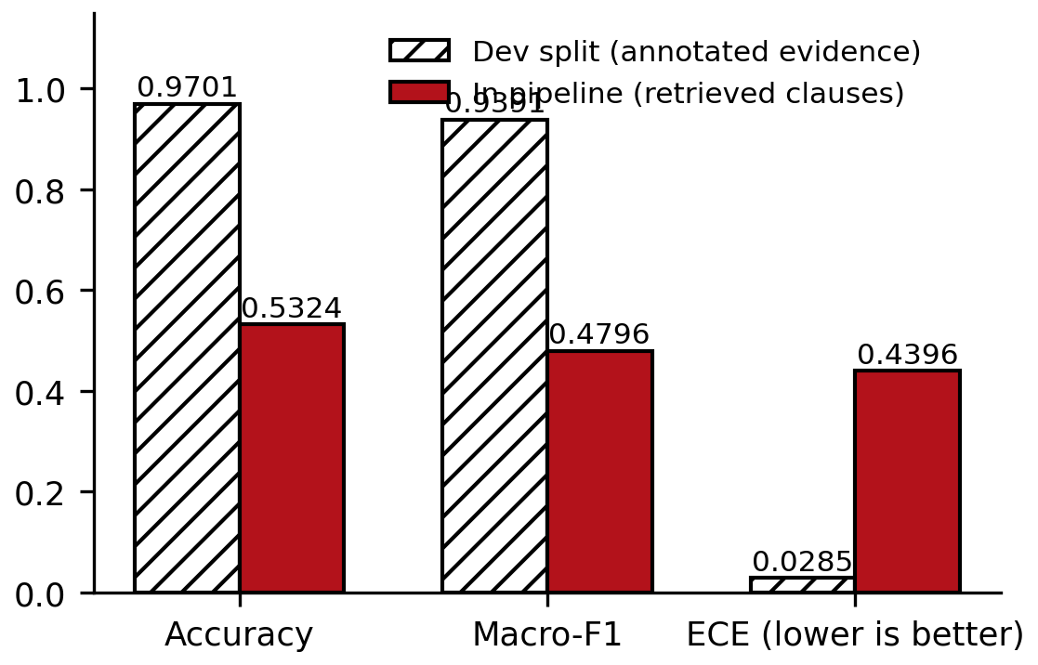
Fig 5.3.3 Dev Split versus In-Pipeline Accuracy, Macro-F1 and ECE

5.3.3 Retrieval Inclusion Test
To isolate retrieval, a test checked, for the Entailment and Contradiction cases of the 123-document test split (1,188 cases), whether the gold evidence clause was among the clauses returned by the retrieval step and the gap filter. Table 5.5 and Figure 5.3.4 show that the gold clause is present in 73.1% of the cases. Since the classifier can only use clauses it receives, this bounds the accuracy of the pipeline on those classes near 73% regardless of the classifier.
Table 5.5 – Retrieval Inclusion of the Gold Evidence Clause
Class | Gold clause retrieved | Cases
Overall | 73.1% | 1,188
Entailment | 72.7%
Contradiction | 74.5%

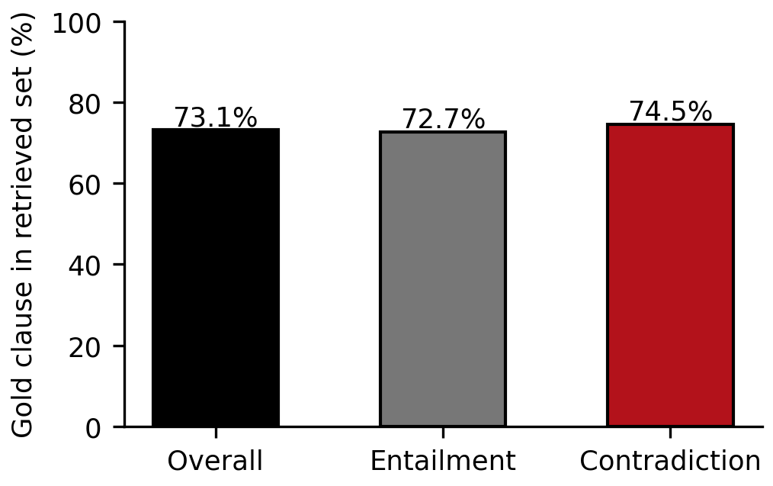
Fig 5.3.4 Retrieval Inclusion of the Gold Clause

5.3.4 Post-Hoc Recalibration
An exploratory study asked whether the confidence could be repaired by recalibration. On the 340 in-pipeline pairs, Platt scaling and isotonic regression were fitted with grouped five-fold cross-validation by document, so that no document appears in both the fitting and the evaluation fold. Table 5.6 and Figure 5.3.5 show that both methods reduce the held-out ECE (0.440 raw, 0.040 with Platt scaling, 0.126 with isotonic regression). However, the AUROC of the confidence for separating right from wrong answers is only 0.61, and after Platt scaling no pair has a calibrated confidence above 0.7, so a reliable threshold would accept essentially none of the cases. With isotonic regression about 12% of the cases could be accepted at an accuracy of 0.667. Recalibration therefore makes the confidence honest but not useful; the underlying ranking has to be improved by retraining. This is an exploratory result on 20 documents.
Table 5.6 – Post-Hoc Recalibration (Exploratory, 20 Documents)
Method | Held-out ECE | Notes
Raw confidence | 0.440 | AUROC of confidence 0.61
Platt scaling | 0.040 | No pair above 0.7; about 0% accepted at a reliable threshold
Isotonic regression | 0.126 | About 12% accepted at accuracy 0.667

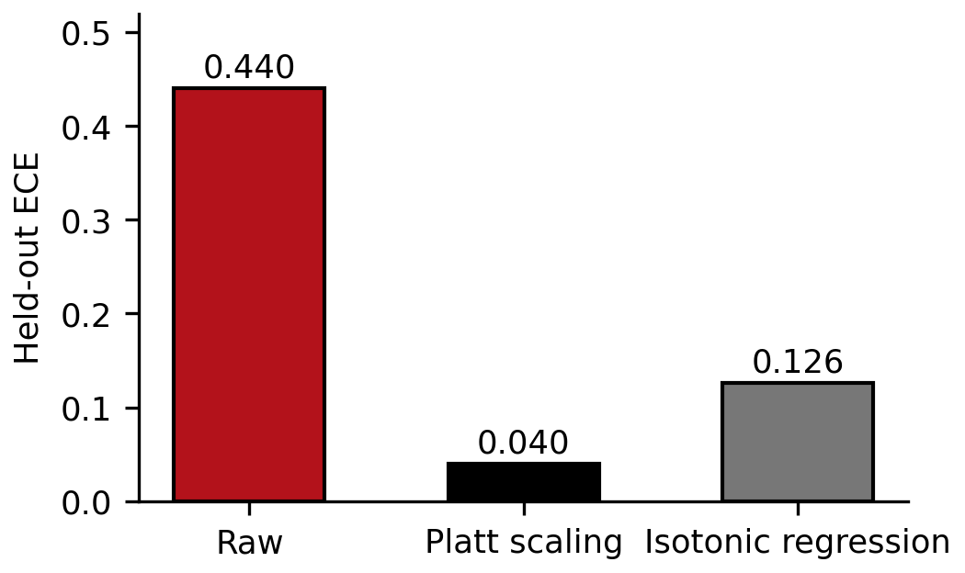
Fig 5.3.5 ECE Before and After Recalibration

5.3.5 Configurations A, B and C
Table 5.7 lists the experiment runs that exist. All were made with the interim Groq LLM and none is paper-grade. Configs A, B and C were run on the same two documents (34 pairs), and Config C alone was run on 20 documents (340 pairs). A matched run of all three configurations on the same 20 documents was started but stopped when the daily token limit of the free LLM tier was reached, so that comparison is pending.
Table 5.7 – Experiment Runs Available (Interim LLM, Not Paper-Grade)
Config | Pairs | Accuracy | Macro-F1 | LLM calls | ECE | Mean s per pair | Status
A | 34 | 0.7647 | 0.6771 | 34 (100%) | n/a | 9.29 | Smoke run, 2 documents
B | 34 | 0.5294 | 0.4501 | 7 (20.6%) | 0.5346 | 2.26 | Smoke run, 2 documents
C | 34 | 0.7647 | 0.6699 | 8 (23.5%) | 0.2418 | 1.95 | Smoke run, 2 documents
C | 340 | 0.5324 | 0.4796 | 37 (10.9%) | 0.4396 | 0.82 | 20 documents
A | 340 | pending | pending | pending | pending | pending | Matched run not completed
B | 340 | pending | pending | pending | pending | pending | Matched run not completed

The three two-document runs cover identical pairs, so the McNemar test could be computed on them (Table 5.7a). Config A and Config C agree on all but six pairs (3 each way), with no detectable difference. Config B is worse than both: it is wrong on 8 pairs that Config A gets right and on 9 pairs that Config C gets right, with only 0 and 1 reverse cases. These results come from 34 pairs of two documents; the 17 hypotheses within a document are not independent, so the p-values are illustrative and must not be read as evidence. The comparison on the full test split with a local LLM has not yet been carried out.
Table 5.7a – McNemar Tests on the Two-Document Smoke Runs (34 Pairs, Exploratory)
Comparison | b (first right, second wrong) | c (first wrong, second right) | Chi-square (corrected) | p-value
A versus C | 3 | 3 | 0.1667 | 0.6831
A versus B | 8 | 0 | 6.1250 | 0.0133
B versus C | 1 | 9 | 4.9000 | 0.0269

5.4 Results
This section shows the application. The screenshots are to be captured from the running application and inserted in the marked places; each box states what the screenshot shows.
[ Fig 5.4.1 Landing Page ]
Landing page introducing EdgeLegal with a call to action to analyze a contract. Insert screenshot here.
Fig 5.4.1 Landing Page
[ Fig 5.4.2 Upload Panel with a Contract Loaded ]
Analyze page showing the uploaded contract in the PDF viewer and the hypothesis input. Insert screenshot here.
Fig 5.4.2 Upload Panel with a Contract Loaded
[ Fig 5.4.3 Analysis in Progress ]
Progress state with the step rail while a hypothesis is being analyzed. Insert screenshot here.
Fig 5.4.3 Hypothesis Input and Analysis in Progress
[ Fig 5.4.4 Verdict Resolved by the Classifier ]
Result card with label, confidence, engine = classifier, cited clause and a decision trail showing that the classifier accepted the case. Insert screenshot here.
Fig 5.4.4 Verdict Resolved by the Classifier (Accept Path)
[ Fig 5.4.5 Verdict Escalated to the LLM ]
Result card showing escalation to the LLM with reasoning and citations. Insert screenshot here.
Fig 5.4.5 Verdict Escalated to the LLM
[ Fig 5.4.6 Citation Jump ]
PDF viewer positioned on the page of the cited clause. Insert screenshot here.
Fig 5.4.6 Citation Jump in the PDF Viewer
[ Fig 5.4.7 History Page ]
History page listing saved analyses with label, confidence, engine and time, with filters and search. Insert screenshot here.
Fig 5.4.7 History Page
[ Fig 5.4.8 Analytics Dashboard ]
Analytics page with usage totals, contradiction rate and classifier versus LLM split. Insert screenshot here.
Fig 5.4.8 Analytics Dashboard
[ Fig 5.4.9 Research Page: Dev Metrics ]
Research page showing dev-split accuracy, macro-F1, ECE, reliability diagram and threshold sweep. Insert screenshot here.
Fig 5.4.9 Research Page: Dev Metrics and Reliability Diagram
[ Fig 5.4.10 Research Page: A/B/C Comparison ]
Research page comparison of configurations with banners for non-paper-grade runs. Insert screenshot here.
Fig 5.4.10 Research Page: A/B/C Comparison

5.5 Performance Evaluation
Table 5.8 gives the time per pair measured by the experiment runner on the two-document and twenty-document runs, split by the engine that produced the answer. A classifier-resolved pair takes about 0.7 to 0.8 seconds on a CPU-only laptop, including retrieval. An LLM-resolved pair in the two-document runs takes 6 to 9 seconds on average through the hosted provider. In the 20-document run the LLM path averaged 1.02 seconds, much lower than in the smaller runs; the reason has not been investigated and may relate to provider load at the time, so the LLM latency figures should not be generalised. Latency with the final local LLM has not been measured.
Table 5.8 – Time per Pair by Engine (Interim LLM)
Run | Engine | n | Mean (s) | 95th percentile (s)
A, 2 documents | LLM | 34 | 9.29 | 16.61
B, 2 documents | Classifier | 27 | 0.75 | 1.22
B, 2 documents | LLM | 7 | 8.09 | 16.01
C, 2 documents | Classifier | 26 | 0.73 | 1.29
C, 2 documents | LLM | 8 | 5.93 | 11.61
C, 20 documents | Classifier | 303 | 0.80 | 1.60
C, 20 documents | LLM | 37 | 1.02 | 1.51

The LLM prompts averaged about 1,100 tokens (maximum about 2,700) and contained about 2.5 clauses; about 98% of calls succeeded at the first attempt in the application logs. The free-tier limits of 30 requests per minute, 1,000 requests per day, 8,000 tokens per minute and 200,000 tokens per day are the practical reason that the matched 20-document run could not be completed. Response times of the individual API endpoints (health, history, analytics, research) have not been measured.

6. CONCLUSION AND FUTURE SCOPE

6.1 Conclusion
EdgeLegal was built as a working contract analysis application with a confidence-gated triage design. A contract is segmented and indexed locally, the clauses relevant to a requirement are retrieved with an adaptive gap filter, a fine-tuned DeBERTa-v3-base classifier labels the pair and reports a confidence, and cases below a frozen threshold of 0.95 are escalated to an LLM that returns a label, reasoning and cited clauses. The application has upload, analysis with a decision trail, history, analytics and research pages, and an experiment runner that compares a no-triage baseline, an off-the-shelf gate and the fine-tuned gate.
The evaluation produced a clear and somewhat negative finding. On the ContractNLI development split the classifier reaches 0.9701 accuracy, 0.9391 macro-F1 and an ECE of 0.0285, so its confidence is trustworthy when it is given annotated evidence. In the full pipeline on 20 test documents the same classifier reaches 0.5324 accuracy and 0.4796 macro-F1, with an ECE of 0.4396, and its high-confidence answers are right only about 55% of the time. Two causes were identified: the classifier is trained on annotated evidence but receives retrieved clauses when it is used, and retrieval returns the gold evidence clause only 73.1% of the time. A recalibration study showed that Platt scaling and isotonic regression can bring the calibration error down to 0.040 and 0.126, but that the confidence ranks right and wrong answers poorly (AUROC 0.61), so calibration alone does not make the gate useful.
Verification covered 17 unit checks and 13 API checks, all of which passed, together with the evaluation runs reported in Chapter 5. These checks cover the application logic, the routing at the threshold, the gap filter, the history store and the calibration and significance computations; they do not replace the end-to-end evaluation.
The conclusions are limited. Only one dataset (ContractNLI, non-disclosure agreements) was used. The LLM used so far is a hosted free-tier model, so none of the pipeline runs is paper-grade. The matched comparison of the three configurations on the same 20 documents is pending, and the comparison on the full 123-document test split with a local LLM has not been carried out. The statement that contract text stays on the user's machine holds only for the local LLM configuration, not for the interim hosted one.

6.2 Future Scope
Retraining on Deployment-Realistic Premises
The classifier should be retrained with premises built by the retrieval pipeline instead of annotated evidence, so that its training inputs match its inputs in use. This is the most direct remedy for the observed failure, and the in-pipeline test and the recalibration study should be repeated afterwards.
Improving Retrieval
The gap threshold should be tuned and hybrid retrieval that combines dense embeddings with lexical matching should be tested, with the retrieval inclusion test of Section 5.3.3 used as the measure. Raising the inclusion rate raises the ceiling on accuracy.
Local LLM and Paper-Grade Evaluation
The experiment runner should be run with a local model through Ollama on the full test split, with repeats and the matched A, B and C configurations and McNemar tests, so that the results can be reported as paper-grade and no contract text is sent to a hosted service.
Within-Document Contradiction Detection
Clauses of the same contract can contradict each other, for example different payment periods in two sections. The in-text subset of the Better Call CLAUSE benchmark [15] offers data to train and evaluate such a layer.
Cross-Document Contradiction Detection
A new agreement can be compared against a company template or a base agreement against its amendments. Pairs derived from ContractNLI could serve as a starting point.
Privacy-Aware Handling of Terms and Conditions
For terms and conditions that govern personal data, a local model could first classify clauses and send only non-sensitive text to a larger hosted model. This idea has not been built or evaluated.
Citation Highlighting
Citations currently navigate to the page of a clause. Highlighting the exact region with bounding boxes would make verification faster.
Other Contract Types and Languages
The system should be extended and tested on contract types other than non-disclosure agreements and on languages other than English.

7. REFERENCES
[1] Y. Koreeda and C. D. Manning, “ContractNLI: A dataset for document-level natural language inference for contracts,” in Findings of the Association for Computational Linguistics: EMNLP 2021, 2021. arXiv:2110.01799.
[2] L. Chen, M. Zaharia, and J. Zou, “FrugalGPT: How to use large language models while reducing cost and improving performance,” arXiv:2305.05176, 2023.
[3] C. Guo, G. Pleiss, Y. Sun, and K. Q. Weinberger, “On calibration of modern neural networks,” in Proc. 34th Int. Conf. Machine Learning (ICML), PMLR 70, 2017, pp. 1321–1330.
[4] “LegalWiz: A multi-agent generation framework for contradiction detection in legal documents,” arXiv:2510.03418, Oct. 2025 (first posted as ContraGen). [Author list to be confirmed from the source.]
[5] I. Chalkidis, M. Fergadiotis, P. Malakasiotis, N. Aletras, and I. Androutsopoulos, “LEGAL-BERT: The muppets straight out of law school,” in Findings of the Association for Computational Linguistics: EMNLP 2020, 2020. arXiv:2010.02559.
[6] P. He, X. Liu, J. Gao, and W. Chen, “DeBERTa: Decoding-enhanced BERT with disentangled attention,” in Int. Conf. Learning Representations (ICLR), 2021. arXiv:2006.03654.
[7] P. He, J. Gao, and W. Chen, “DeBERTaV3: Improving DeBERTa using ELECTRA-style pre-training with gradient-disentangled embedding sharing,” arXiv:2111.09543, 2021.
[8] T. Schuster et al., “Confident adaptive language modeling,” in Advances in Neural Information Processing Systems (NeurIPS), 2022. arXiv:2207.07061.
[9] S. Jeong et al., “Adaptive-RAG: Learning to adapt retrieval-augmented large language models through question complexity,” in Proc. NAACL, 2024.
[10] “Dynamic model routing and cascading for efficient LLM inference: A survey,” arXiv:2603.04445, 2026. [Author list to be confirmed from the source.]
[11] “Can small models reason about legal documents? A comparative study,” arXiv:2603.25944, 2026. [Author list to be confirmed from the source.]
[12] “Deterministic fuzzy triage for legal compliance classification and evidence retrieval,” arXiv:2603.07390, 2026. [Author list to be confirmed from the source.]
[13] “ContraVis,” arXiv:2609.27014, 2026. [Title and author list to be confirmed from the source.]
[14] Y. An, Z. Wu, Z. Yang, S. Zhou, Y.-Q. Yin, X. Wang, and P. Qin, “Multi-agent orchestration of local LLMs for contract review under resource constraints,” in Proc. 5th Int. Conf. Big Data, Artificial Intelligence and Risk Management (ICBAR), Dongguan, China, 2025, doi:10.1145/3800227.3800266. [Abstract not accessible; not assessed.]
[15] “Better Call CLAUSE: A discrepancy benchmark for auditing LLMs legal reasoning capabilities,” in Findings of the Association for Computational Linguistics: EACL 2026. arXiv:2511.00340. [Author list to be confirmed from the source.]
[16] “ContractEval: Benchmarking LLMs for clause-level legal risk identification in commercial contracts,” in Proc. Natural Legal Language Processing Workshop (NLLP), 2025. arXiv:2508.03080. [Author list to be confirmed from the source.]
[17] J. C. Platt, “Probabilistic outputs for support vector machines and comparisons to regularized likelihood methods,” in Advances in Large Margin Classifiers. Cambridge, MA, USA: MIT Press, 1999, pp. 61–74.
[18] B. Zadrozny and C. Elkan, “Transforming classifier scores into accurate multiclass probability estimates,” in Proc. 8th ACM SIGKDD Int. Conf. Knowledge Discovery and Data Mining, 2002, pp. 694–699.
[19] Q. McNemar, “Note on the sampling error of the difference between correlated proportions or percentages,” Psychometrika, vol. 12, no. 2, pp. 153–157, 1947.
[20] S. Xiao, Z. Liu, P. Zhang, and N. Muennighoff, “C-Pack: Packaged resources to advance general Chinese embedding,” arXiv:2309.07597, 2023 (BGE embedding models).
[21] OpenAI, “gpt-oss-120b and gpt-oss-20b model card,” 2025.

APPENDIX

I. Code Snippets
The snippets below are copied from the repository files named in each caption; docstrings are omitted where marked.
A.1 Adaptive gap filter (backend/app/vectorstore/chroma_client.py)
def gap_filter(
candidates: list,
gap_threshold: float = GAP_THRESHOLD,
) -> list:
"""(docstring omitted)"""
if not candidates:
logger.debug("gap_filter() called with 0 candidates.")
return []

kept = [candidates[0]]
best_score = candidates[0][1] # fixed anchor — never updates
ceiling = best_score * (1.0 + gap_threshold)

for clause, score in candidates[1:]:
if score <= ceiling:
kept.append((clause, score))
else:
break # outside the relevance band of Rank-1 — stop

logger.debug(
"gap_filter: kept %d/%d candidates (rank1=%.4f, ceiling=%.4f)",
len(kept), len(candidates), best_score, ceiling,
)
return kept

A.2 Confidence check node (backend/app/agent/nodes.py)
def confidence_check_node(state: AgentState) -> dict:
"""
Compares triage confidence against the frozen threshold and decides
whether to accept the classifier's label directly or escalate to the LLM.

Reads: triage_confidence, threshold
Writes: routing_decision ("accept" | "escalate")
"""
confidence = state["triage_confidence"]
threshold = state["threshold"]
decision = "accept" if confidence >= threshold else "escalate"
log_step(logger, "route.decision", doc_id=state.get("document_id", "?"),
confidence=round(confidence, 4), threshold=threshold, decision=decision)
return {"routing_decision": decision}

A.3 Routing graph (backend/app/agent/graph.py)
def build_graph():
"""
Build and compile the confidence-routed triage graph:

retrieve -> triage -> confidence_check --accept----> accept -> END
| \--escalate--> call_llm -> END
\--skip_triage (Config A) -----------------------> call_llm -> END

Returns:
A compiled graph exposing .invoke(initial_state) -> AgentState.
"""
graph = StateGraph(AgentState)

graph.add_node("retrieve", retrieve_node)
graph.add_node("triage", triage_node)
graph.add_node("confidence_check", confidence_check_node)
graph.add_node("accept", accept_node)
graph.add_node("call_llm", call_llm_node)

graph.set_entry_point("retrieve")
graph.add_conditional_edges(
"retrieve",
_after_retrieve,
{"triage": "triage", "call_llm": "call_llm"},
)
graph.add_edge("triage", "confidence_check")
graph.add_conditional_edges(
"confidence_check",
_route,
{"accept": "accept", "escalate": "call_llm"},
)
graph.add_edge("accept", END)
graph.add_edge("call_llm", END)

compiled = graph.compile()
logger.debug("Confidence-routed triage graph compiled "
"(nodes: retrieve, triage, confidence_check, accept, call_llm)")
return compiled

A.4 Expected calibration error (backend/app/triage_model/evaluate.py)
def compute_calibration(
confidences: Sequence[float], correct: Sequence[bool], n_bins: int = 10
) -> ECEResult:
"""(docstring omitted)"""
n_bins = max(n_bins, 1)
bin_conf_sums = [0.0] * n_bins
bin_correct_sums = [0.0] * n_bins
bin_counts = [0] * n_bins

for conf, is_correct in zip(confidences, correct):
b = min(int(conf * n_bins), n_bins - 1)
bin_conf_sums[b] += conf
bin_correct_sums[b] += float(is_correct)
bin_counts[b] += 1

bin_confidences = [
(bin_conf_sums[b] / bin_counts[b]) if bin_counts[b] else 0.0
for b in range(n_bins)
]
bin_accuracies = [
(bin_correct_sums[b] / bin_counts[b]) if bin_counts[b] else 0.0
for b in range(n_bins)
]

total = sum(bin_counts)
ece = 0.0
if total > 0:
for b in range(n_bins):
if bin_counts[b] == 0:
continue
ece += (bin_counts[b] / total) * abs(bin_accuracies[b] - bin_confidences[b])

return ECEResult(
ece=ece,
bin_confidences=bin_confidences,
bin_accuracies=bin_accuracies,
bin_counts=bin_counts,
)

A.5 McNemar test (backend/app/experiment_runner.py)
def compute_significance(results_a: ResultsDict, results_b: ResultsDict) -> McNemarResult:
"""(docstring omitted)"""
from scipy.stats import chi2

index_a = {(r.doc_id, r.hyp_id): r for r in results_a.rows}
index_b = {(r.doc_id, r.hyp_id): r for r in results_b.rows}

if index_a.keys() != index_b.keys():
raise ValueError(
"results_a and results_b must cover the exact same (doc_id, hyp_id) "
"pairs — run both configs on the same test split."
)

b = 0 # A correct, B wrong
c = 0 # A wrong, B correct
for key, row_a in index_a.items():
row_b = index_b[key]
if row_a.correct and not row_b.correct:
b += 1
elif not row_a.correct and row_b.correct:
c += 1

if b + c == 0:
return McNemarResult(statistic=0.0, p_value=1.0, significant_at_05=False, b=b, c=c)

statistic = (abs(b - c) - 1) ** 2 / (b + c)
p_value = float(1 - chi2.cdf(statistic, df=1))

return McNemarResult(
statistic=statistic,
p_value=p_value,
significant_at_05=p_value < 0.05,
b=b,
c=c,
)

A.6 History schema (backend/app/history_db.py)
SCHEMA = """
CREATE TABLE IF NOT EXISTS documents (
id TEXT PRIMARY KEY,
filename TEXT NOT NULL,
uploaded_at TEXT NOT NULL,
page_count INTEGER
);
CREATE TABLE IF NOT EXISTS analyses (
id INTEGER PRIMARY KEY AUTOINCREMENT,
document_id TEXT NOT NULL REFERENCES documents(id) ON DELETE CASCADE,
hypothesis TEXT NOT NULL,
label TEXT NOT NULL,
confidence REAL,
source TEXT CHECK (source IN ('classifier', 'llm')),
created_at TEXT NOT NULL,
report_json TEXT NOT NULL
);
CREATE INDEX IF NOT EXISTS idx_analyses_created_at ON analyses(created_at DESC);
CREATE INDEX IF NOT EXISTS idx_analyses_document_id ON analyses(document_id);
"""

A.7 Platt scaling and isotonic regression (backend/app/recalibration_preview.py)
def fit_platt(conf, ok, iters=200, lr=0.1):
a, b = 1.0, 0.0
xs = [logit(c) for c in conf]
for _ in range(iters):
ga = gb = 0.0
for x, y in zip(xs, ok):
p = 1 / (1 + math.exp(-(a * x + b))); ga += (p - y) * x; gb += (p - y)
a -= lr * ga / len(xs); b -= lr * gb / len(xs)
return lambda c: 1 / (1 + math.exp(-(a * logit(c) + b)))

def fit_isotonic(conf, ok):
pts = sorted(zip(conf, ok)); blocks = [[p[1], 1, p[0], p[0]] for p in pts] # sum, n, lo, hi
i = 0
while i < len(blocks) - 1:
if blocks[i][0] / blocks[i][1] > blocks[i + 1][0] / blocks[i + 1][1]:
s, n, lo, _ = blocks[i]; s2, n2, _, hi2 = blocks[i + 1]
blocks[i:i + 2] = [[s + s2, n + n2, lo, hi2]]; i = max(i - 1, 0)
else: i += 1
def f(c):
for s, n, lo, hi in blocks:
if c <= hi: return s / n
return blocks[-1][0] / blocks[-1][1]
return f

II. Screenshots (Input, Process and Output)
The screenshots are to be captured from the running application. Each box states what the screenshot shows.
[ A.1 Input: Upload ]
Upload panel with the contract selected. Insert screenshot here.
Fig A.1 Input: Contract Upload
[ A.2 Input: Hypothesis ]
Hypothesis entry with a requirement typed. Insert screenshot here.
Fig A.2 Input: Hypothesis Entry
[ A.3 Process: Indexing and Analysis ]
Indexing and analysis in progress with the step rail. Insert screenshot here.
Fig A.3 Process: Indexing and Analysis in Progress
[ A.4 Process: Decision Trail ]
Decision trail showing retrieve, triage, confidence check and accept or escalate. Insert screenshot here.
Fig A.4 Process: Decision Trail
[ A.5 Output: Result ]
Result with label, confidence, engine and cited clauses. Insert screenshot here.
Fig A.5 Output: Result
[ A.6 Output: History ]
History list with filters. Insert screenshot here.
Fig A.6 Output: History
[ A.7 Output: Analytics ]
Analytics dashboard. Insert screenshot here.
Fig A.7 Output: Analytics
[ A.8 Output: Research ]
Research page with metrics and the A/B/C comparison. Insert screenshot here.
Fig A.8 Output: Research

